Syllabus for B.Tech II year II semester
Computer Science and Engineering
IT Workshop
L | T | P/D | C
0 | 0 | 3 | 1.5

Code: 9FC64

Course Objectives
Students will try to learn
- Basics of Python programming, Decision Making and Functions in Python, Object Oriented Programming using Python.
- To introduce to a personal computer and its basic peripherals, the process of assembling a personal computer, installation of system software like MS Windows, Linux and the required device drivers.

Course outcomes
At the end of this course, student is able to
- Apply knowledge for computer assembling and software installation and ability to solve the trouble shooting problems.
- Apply the tools for preparation of PPT, Documentation and budget sheet etc.
- Install and run the Python interpreter ,Create and execute Python programs.
- Apply the best features of mathematics, engineering and natural sciences to program real life problems.
- Describe the Numbers, Math functions, Strings, List, Tuples and Dictionaries in Python, Express different Decision Making statements and Functions, Interpret Object oriented programming in Python.
- Understand and summarize different File handling operations, explain how to design GUI Applications in Python.
Week 1:
Introduction to Computer: Identify the peripherals of a computer, components/peripherals in a CPU & its functions. Introduction to the types of Operating System, Assembling and disassembling demonstration.

Week 2:
Install computer with dual boot operating system (Windows, Linux with PowerPoint presentation). Comparison of types of OS in different platform

Week3:
Introduction to S/W's, difference b/w hardware and software. Introduction to MS-Office and its importance.
Ms Word
Ms Power Point Presentation

Week4:
Introduction to Excel
Features: Accessing, Overview at toolbars, saving excel files, Gridlines, Format cells, Summation, Auto fill, formatting text.
Formula in excel – Average, Standard Deviation, Charts, Roaming & Inserting worksheets, Hyper linking, count function, lookup / Vlookup, sorting, Conditional formatting.

Week 1:
Introduction to Computer: Identify the peripherals of a computer, components/peripherals in a CPU & its functions. Introduction to the types of Operating System, Assembling and disassembling demonstration.

Definition: A computer is a fast electronic device that processes the input data according to instructions given by programmer/user and provides the desired information as output.

Computers Have Two Main Parts
- Computer Hardware
- Computer Software
- Hardware
- The hardware is the part of the computer you can touch and see.
- The computer and all equipment attached to it are called hardware.
- Example: Monitor, Keyboard, Mouse
- Software
- Software is a part of the computer you cannot touch.
- The instructions that tell it what to do are called software.
- Software consists of computer programs and procedures that perform some tasks on your computer.
- Computer software is divided into three basic types
- System software
- Application software
- Programming software
- System software :
Operating System is the base program on a computer is considered system software. It tells the computer how to work or operate. The operating system also allows you to load other programs that do specialized tasks on to your computer. (ex. Windows XP and Vista
- Application software:
Application software allows you to accomplish one or more specific (non-computer related) tasks. Such as computer games for entertainment or Microsoft Word for typing
- Programming software
Programming software provides tools to assist a computer programmer in writing programs and software.
- Block Diagram of Computer

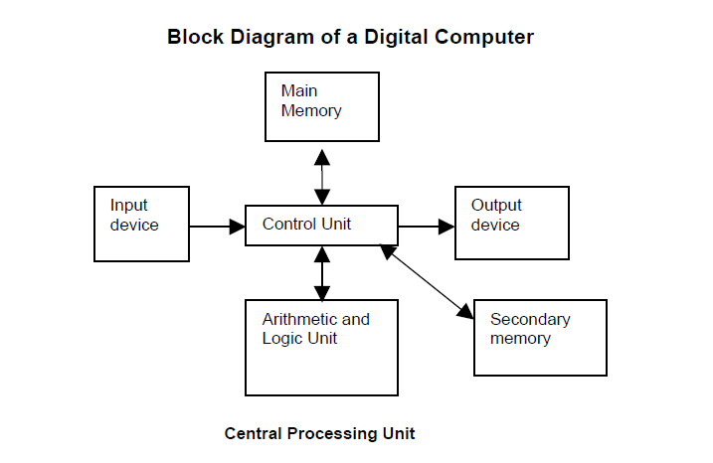
- Central Processing Unit (CPU)

- It performs all the processing of input data. In microcomputers, the CPU is built on a single chip or integrated Circuit (IC) and is called as a Microprocessor.

- CPU consists of following parts:
1. Arithmetic Logic Unit (ALU)
2. Control Unit (CU)
3. Memory Unit (MU)
4. Registers
5. Buses
6. Clock

- Memory Unit

It is used to store the data, instructions and information before, during and after the processing by ALU. It is also known as Main/Primary/Internal Memory.
It is divided into 3 types:
1. Read Only Memory (ROM)/Non-Volatile Memory
2. Random Access Memory (RAM)/ Volatile Memory
3. Complementary Metal Oxide Semiconductor Memory (CMOS)
- Read Only Memory (ROM)/Non-Volatile Memory

ROM is permanent and is not erased when system is switched off. ROM is also called Nonvolatile Memory. Memory capacity varies from 64 KB to 256 KB (1 KB = 1024 bytes).
- Types of ROM
1. Mask ROM
2. PROM (Programmable Read Only Memory)
3. EPROM (Erasable Programmable Read Only Memory)
4. EEPROM (Electrically Erasable Programmable Read Only Memory)
5. EAPROM (Electrically Alterable Programmable Read Only Memory)

- Random Access Memory (RAM)/ Volatile Memory
RAM is temporary and is erased when the computer is switched off. RAM is also called volatile Memory. Memory capacity varies from 640 KB to several megabytes (1 Megabyte = 1024 KB).
- Types of RAM
1. Dynamic RAM (DRAM)
2. Static RAM (SRAM)

Differences between Dynamic RAM & Static RAM
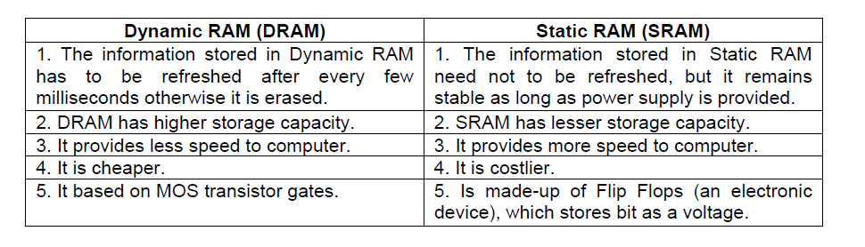

- Complementary Metal Oxide Semiconductor Memory (CMOS)
CMOS is used to store the system configuration, time, date and other important data.
- Input Devices: devices through which computer receives the information
    - Keyboard
    - Mouse
    - Scanner
- Output Devices: The output device is used to display or print result from a computer
    - Monitor
    - Printers
    - Plotter
- PROGRAMMING LANGUAGES CLASSIFICATION

1. Machine Languages / First Generation Languages

2. Assembly Languages / Second Generation Languages

3. High Level Languages

1. Machine Languages / First Generation Languages

Each processor or CPU has its own set of instructions. These instructions are binary instructions and written in a sequence of ‘0’s and ‘1’s.

Any program written by using the binary instructions are known as machine language.

Machine language for every processor is different. Writing a program in machine language is very burden and difficult.

Advantages: The advantage of the machine language code is that a processor can execute it without any transaction.

Assembly Language / Second Generation Languages

- The processor cannot understand the code written in assembly language. So, it would not be able to execute assembly language instructions.
- The processor understands the machine language. So, assembly language programs have to be converted into machine language. This is done by the assembler.
- Assembler: The assembler is a program, which converts an assembly language program into machine code (object code), which can be executed by the processor.
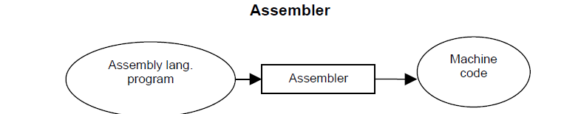
- Advantages: The advantage of the assembly language over machine language is that it is more convenient for the programmer to write programs in assembly language.
- High Level Languages (HLL)
- High-level languages are machine independent. So, it is not necessary to know the architecture details of a processor to write the programs in these languages.
Ex: COBOL, BASIC, PASCAL, ADA, C etc.
- Advantages: Writing programs in High Level Languages is more easy because they provide the construct and set of statements which are easy to use.
- Writing a program for problem in higher-level language is easier than machine and assembly language. So, program development time in high-level language is low.
Translation of High-level language Program – Compiler/Interpreter
- The program written in a high-level language needs to be translated into the language, which a machine understands. Translation of a program from high-level language to low level language is done by the software called Compiler & Interpreter.
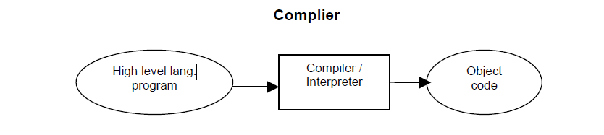 Differences between Compiler & Interpreter
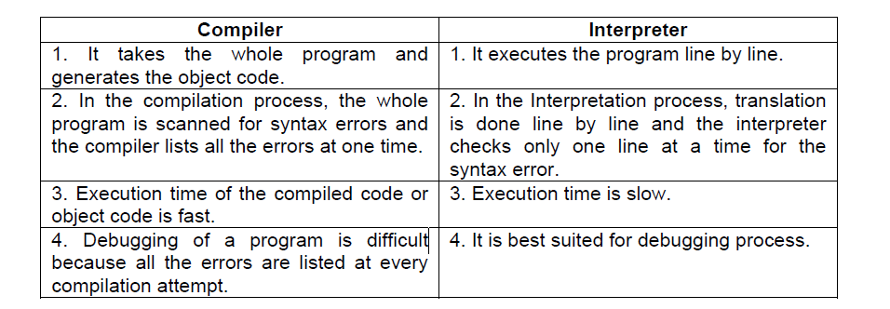

Parts of a Computer

To learn more about the components of a computer, let us examine the various parts that are visible from outside. Basically, a computer consists of a CPU, a monitor, a mouse and a keyboard. Some Computers may also contain additional accessories like speakers, a microphone, a headphone etc. The additional accessories simply facilitate us to use the computer fro doing something extra. A discussion on the essential and optional components of the computer will be taken up later on in this chapter. For the moment, let us discuss the components of a simple computer.

Central Processing Unit: The Central Processing Unit (CPU) of computer is usually located in a tower-shaped cabinet. The CPU consists of different smaller components like the motherboard, hard disk, RAM, floppy disk drive, sound card etc. These components are discussed in the next section.

Monitor: Monitor is a television-like equipment which displays the output of a computer. Monitors can be monochrome (black and white), LCD (liquid crystal display), VGA or SVGA. Further, monitors can be analogue or digital.

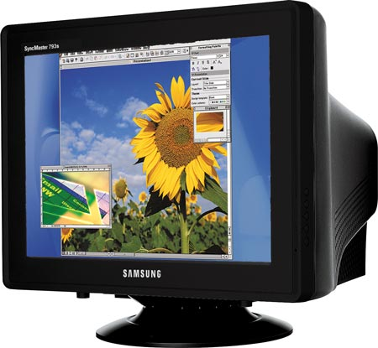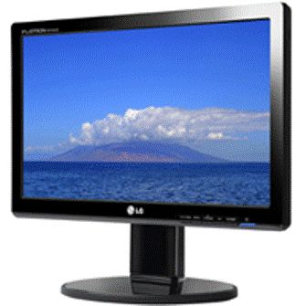

Mouse: Mouse is a small component that fits inside out palm. It contains buttons (two or three) which help us work on a computer conveniently.

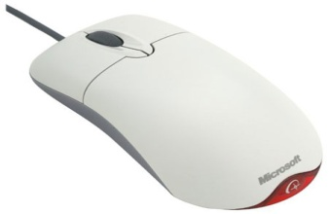

Keyboard: Keyboard is a typewriter like device which contains key to feed information into the computer.
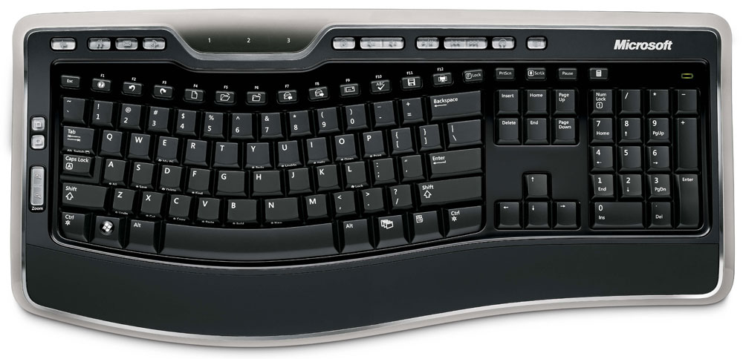

Components of a PC
Basic Components | Optional
- Processor  - Hard disk  - RAM  - Display / Video card  - Keyboard  - Drives : Hard Disk, Floppy Disk and CD-ROM  - Mouse  - Monitor | - Printer  - Scanner  - Modem  - DVD drive  - Speakers  - Zip Drive

The System Unit
The Keyboard, monitor, mouse, printer, etc. are all linked to the System Unit through cables which are plugged into the back of the System Unit. The hard disk, the floppy disk drive and the CD-ROM drive are placed inside this unit.

Vital components of the System Unit.

- Hard Disk: The hard disk is a device which stores all programs and data in the computer. The capacity of the hard disk is measured in Giga Bytes (GB). Larger the hard disk capacity, more the amount of software programs and information that can be stored in it.
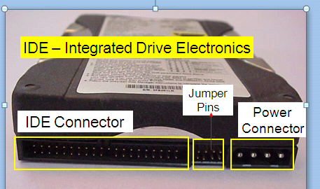

- Motherboard: The motherboard is a flat platform of fibre glass on which the electronic components in a PC are mounted. The motherboard is also called a Printed Circuit Board (PCB)
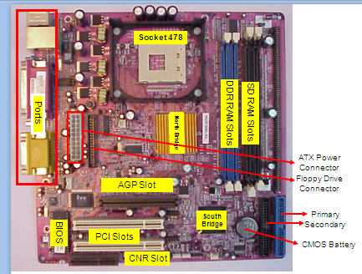
- Central Processing Unit (CPU): The Central Processing Unit (CPU) contains the microprocessor chip which undertakes all the thinking for the PC and runs the programs according to the user’s commands and requests.
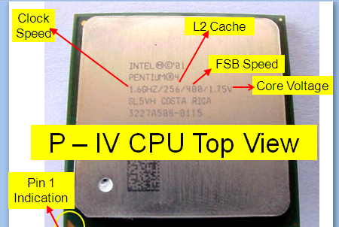

Following are the various types of CPU chips:
  - Pentium
  - Pentium Pro
  - Pentium III
  - Pentium IV
  - AMD Athlon
  - Intel Celeron
  - AMD Duron
  - Cyrix

- CD-ROM Drive: CD-ROM drive is a device that reads the information stored on CD-ROM disks, CD-ROM is an abbreviated term for ‘Computer Disk – Read Only Memory’. The Speed of a CD-ROM drive is indicated by a number followed by the alphabet ‘X’. The 56X CD-ROM is currently the most popular drive specification. The CD-ROM disk is flat and circular in shape and can store a lot more information as compared to a floppy disk.

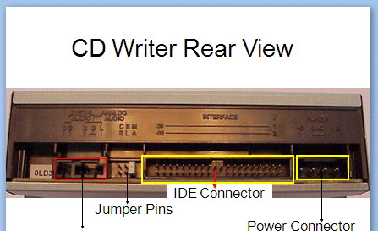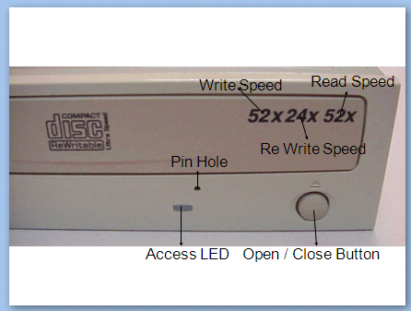

- Floppy Disk Drive: Floppy disk drive is a component that enables us to read/store information on floppy disks. The floppy disk drive consists of a slot to accept a floppy disk, a motor to spin the disk, and a recording/reading device that moves across the disk to read or write data. A floppy disk (also called diskette) is used to store information just as hard disk. It is a removable device, its capacity is (1.44 MB). A PC has 3½ “ floppy disk drive.
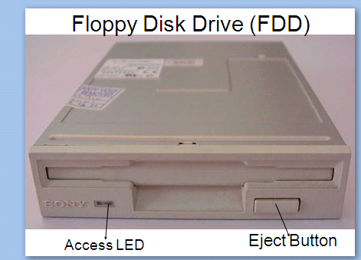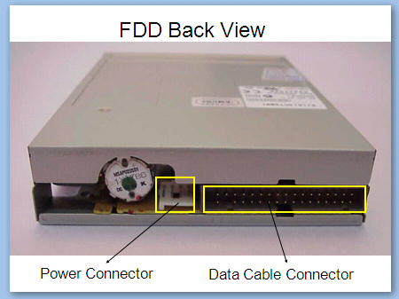

- Math Co-processor Slot: Some PCs contain a slot where a Math Co-processor can be inserted. This processor assists the CPU in performing its mathematical operations. Computers above the 486 grade, Math Co-processor is already in-built in the CPU chip.

- RAM Chips: RAM stands for Random Access memory, RAM chips are components that help the computer to hold the program and it data temporarily while the computer is working. RAM chips come in memory sizes of 16 MB, 32 MB, 64 MB, 128 MB and so on.

- RAM Chip Slots: These slots are meant to expand the computer’s random access memory by incorporating additional RAM chips.

- Over-Drive Chip: The Over-Drive chip increases the processing speed so that the performance of the computer is improved.

- SCSI: SCSI stands for ‘Small Computer System Interface’ (pronounced skuzzy). An SCSI provides an internal connector which in turn allows to connect the computer to an external storage dev ice.

- Power Supply Unit: The components in a PC can work only when they get electric supply. Most components require a 5 Volt supply while the floppy and the hard disk require about 12 Volts. The power supply unit safeguards the PC components by converting high-voltage current to low voltage.

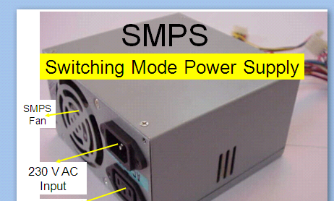

- Disk Drive Control Card: This stand controls the disk drive motors of the PC and transfers data to the control circuitry and directs the read/write heads to access data on the disk. It is permanently inserted in the motherboard.

- Display/Video/Graphic Card: Display card is used to display the data to the user. It is indirectly linked with the computer memory. Nowadays, it is inbuilt in the motherboard. Two types of display cards are available. PCI graphics card and the AGP card.

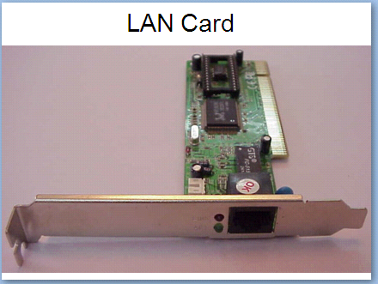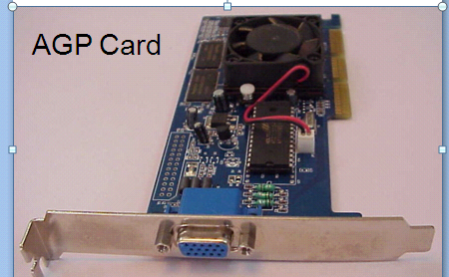

- Printer Adaptor Card: The display / printer adaptor card is the link between the PC’s memory, the monitor and the printer. It displays the information on the monitor as well as allows it to be printed.

- Expansion Slots: Expansion slots are long and narrow connectors which allow to plug in expansion cards (also called adaptor cards), like the sound card, network card etc.

- ROM Chips: Read Only Memory (ROM) chips have data written on them during manufacturing, that tells the CPU the tasks that it needs to carry out when the CP switched on.

- Sound Card: This card allows you to play sound and music. The sound card converts the digital information into electrical signals that speakers use. When the speaker is connected to the sound card, the sound can be heard on the speaker.

The Front Part of a System Unit
The various components seen in the front part of a System Unit and their functions:
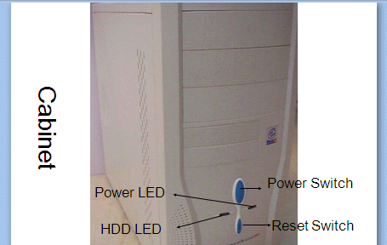

a) Power switch: The power on/off switch is used to turn on or off the power to the PC.

b) Reset button: This button helps to restart the computer without disconnecting the power supply.

c) Lights: The front panel of the system unit may display a variety of cloloured indicator lights including power and turbo signals. These lights are used to indicate whether the hard disk, the floppy disk or the CD-ROM is being read or written.

d) Floppy Disk Drive: The System Unit contains a slit in which the floppy disk can be inserted.

e) CD-ROM Drive: CD-ROM drive is used for reading the information stored on CD-ROM disks.

f) Removable Storage Drives: Removable storage drive is an external device that can be connected to the computer are CD writers and rewriters.

The Backside of a System Unit
The back of the System Unit contains ports of various types. These are the Parallel Port, the Serial Port and the Universal Serial Bus (USB).
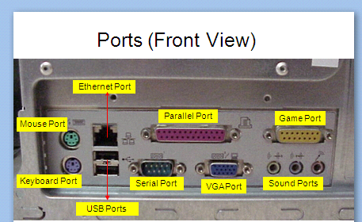

Power IN and OUT Sockets: The sockets have cables plugged into them, which carry the power from the electrical outlet to the System Unit, and from the System Unit to the monitor.

Serial Ports: Serial ports connect the PC to a mouse or a modem. Most PCs are fitted with two serial ports.

Video/Monitor Port: A cable from the monitor plugs into the video/monitor port and carries the information to be displayed on the monitor.

Parallel port: The parallel port is usually used for connecting the computer to a printer. Very often, it is referred to as the printer port. Its data transfer speed is about eight times faster than the serial port.

Keyboard Port: The cable from the keyboard plugs into the keyboard port.

USB Port: A USB port is used for connecting any device with a USB connection.

Fan Housing: During operation, the electronic, components in a PC generate a lot of heat, which is liable to overheat the system. To remove excess heart from the system, fan is placed at the back of the unit.

Audio jack: An audio jack is used for connecting devices such as speakers headphones or microphones.

Modem jack: This jack is mainly used in case of internal modems.

SCSI port: The Small Computer System Interface (SCSI) port is used to connect the external hard drive, the DVD drive or the scanner.

Network port: The network port allows you to connect a computer to other computers in a netwo

Task-2: To explain the process of assembling and disassembling the CPU.

- Setting up a System

Setting up a system i.e. connecting the monitor, System Unit, keyboard, the mouse and the UPS

- The keyboard has a plug which is round in shape and has 5 small pins. Connect this plug to the tower (A).
- The plug of the mouse goes to the tower or the system unit at the back (B).
- The monitor has two plug cables. One of these cables connects to the tower (C).
- The printer plug is connected to the tower (D).
- The speakers are connected to the tower (E).

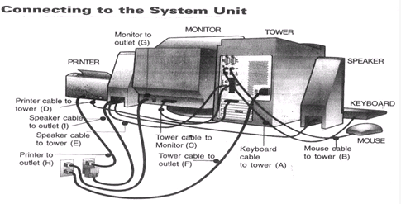

- The keyboard has a plug which is round in shape and has 5 small pins. Connect this plug to the tower (A).
- The plug of the mouse goes to the tower or the system unit at the back (B).
- The monitor has two plug cables. One of these cables connects to the tower ( C ).
- The printer plug is connected to the tower (D).
- The speakers are connected to the tower (E).

- Connecting the Electrical Wires

- The system unit or the tower to the outlet (F).
- The monitor has two cables and one of them carries the electrical supply. Connect the monitor to the outlet (G).
- The printer plug should be connected to the electrical supply (H).
- The plug carrying the electrical current to the speaker should be connected to the outlet (I).

- Turning on the System

- Switch on the outlet button from where the computer is getting the power.
- Push on the POWER button located on the front of the tower or the system unit. a light will glow indicating that the system is switched on. You may also hear whirring noises. This means that your system is booting up.
- Switch on the button on the monitor. This will start the monitor and will be indicated by a light.
- Wait for the computer to complete the booting process and display the next item i.e. the box that enables you to log on to Windows by providing a password.

- Logging on

After turning on a system, you will want to establish ownership. This is called logging on. If your computer connected to a network, a box will popup and ask you to type in your user name and password. Usually, the user name is your last name, but it can be anything.

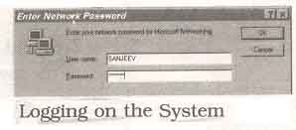

- Disassembling a PC

- Requirements for Disassembling:

- P.C Which is assembled
- Screw driver
- Cutting player
- Tester

- Procedure:

- Step1: Shut down the PC if it is running
- Step2: Switch of power supply and remove power cables from the power supply switch.
- Step3:Remove all the cables connected to CPU i.e.,.
- Power plugs which are connected to CPU and Monitor
- . Remove all the cables from Input/ output panel ports.
- Display cable
- Keyboard
- Mouse
- Printer and LAN
iii. Input/ output Ports available are:

- Display port
- Ps/2 Port
- USB Port [ universal serial bus]
- LAN and Printer Port
- Audio ports
- Serial Port
Step4: Remove the screws of the slides from the cabinet and then remove the slides from the Cabinet

tep5:Remove the power cables and data cables which are connected to mother board and hard disk, CD-Drive , Floppy Drive.

Step6: Remove the front panel cables from the motherboard which are power –led , key switch, hard disk ,drive led, Reset switch led, turbo switch led.

Step7: Remove the cable of Mother Board speakers.

Step8: Remove the screws of SMPS and Remove SMPS from the Cabinet.

Step9: Remove all expansion cables from motherboard which are LAN, MODEM, Display…

Step10: Remove the screws of Hard Disk , CD-Drive and Floppy drive and then remove Hard Disk, CD-Drive , Floppy drive from the Cabinet.

Step11: Remove the Screws of Mother Board and then remove motherboard from the cabinet.

Step12: Remove the Locks of RAM and then remove the RAM from motherboard

Step13:Remove the Power cable of processor Fan.

Step14: Remove the Locks of Processor fan and the Remove Fan from the Processor.

Step15: Remove the heat sinker from Processor.

Step16: Open interlocks of processor and then remove the processor from processor slots/slogs.

Step17: Remove the CMOS Battery (Locks) from the Motherboard

- ASSEMBLING

- REQUIREMENTS FOR ASSEMNLING THE P.C TOOLS:-

- Screw Driver
- Cutting Player
- Tester
- COMPONENTS FOR P.C:

- Case
- Mother Board (ATX & NLX)
- Connectors
- Power supply
- Front Panel (power switch led)
- Back I/O panel (serial, parallel , USB Ports)
- Expansion Slots
- Memory module
- CPU
- Fans and Filters.

- Steps Required for P.C ASSEMBLING:

- Step1: Installation of CPU(Follow motherboard Manual)Install Heat sinker Fan, do CPU arrangements , CPU sockets and Slots.

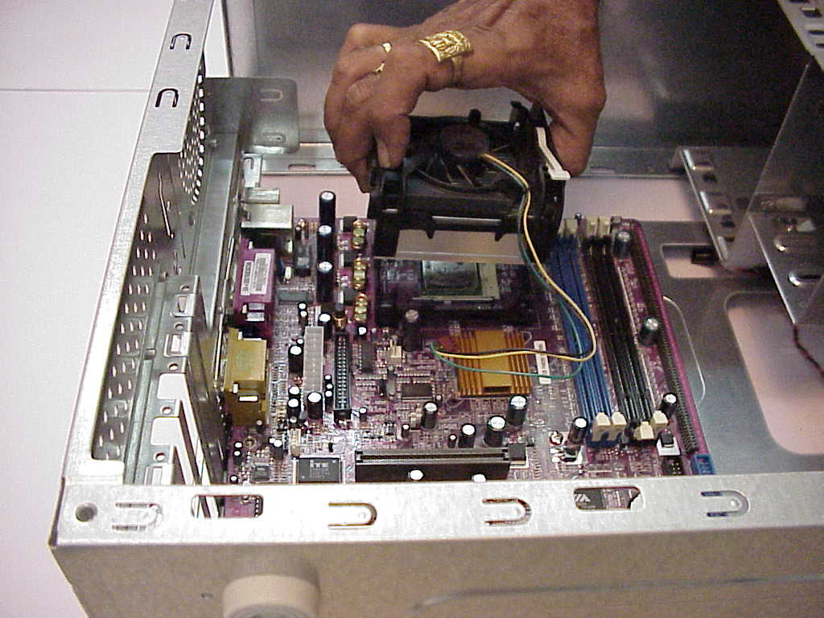

- Step2: Installation of Memory , SDR and DDR Memory.

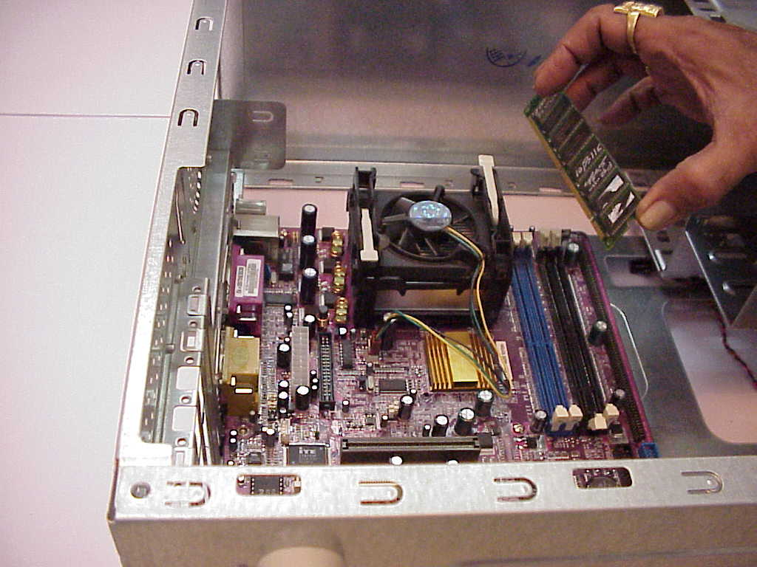

- Step3: CMOS Battery installation (configure, Clock speed, Jumper and multiplier Jumper)

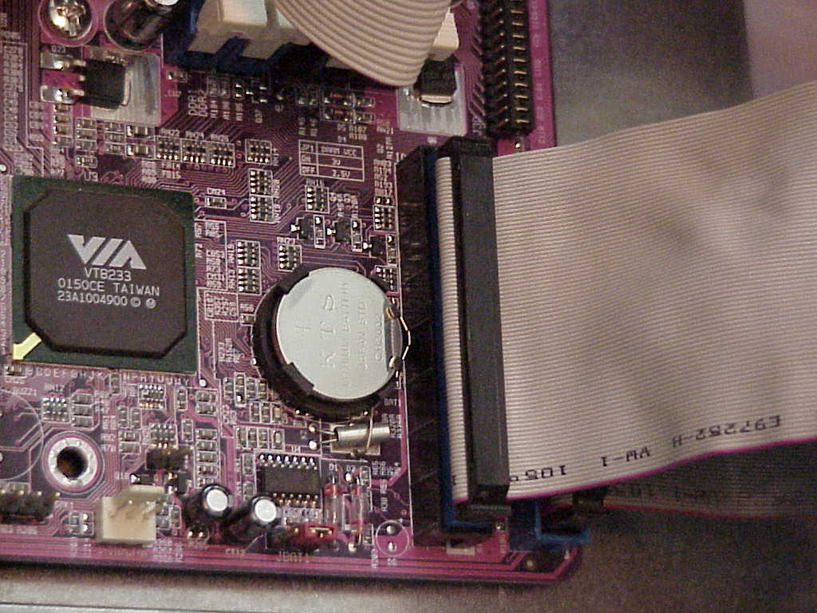

- Step4: Install motherboard is case. Install wires for front panel and mother power connectors.

- Take antistatic precautions property mount motherboard and screws it with screws gently, properly aligns expansion slots and ensure ports. Proper accessibility at the back.
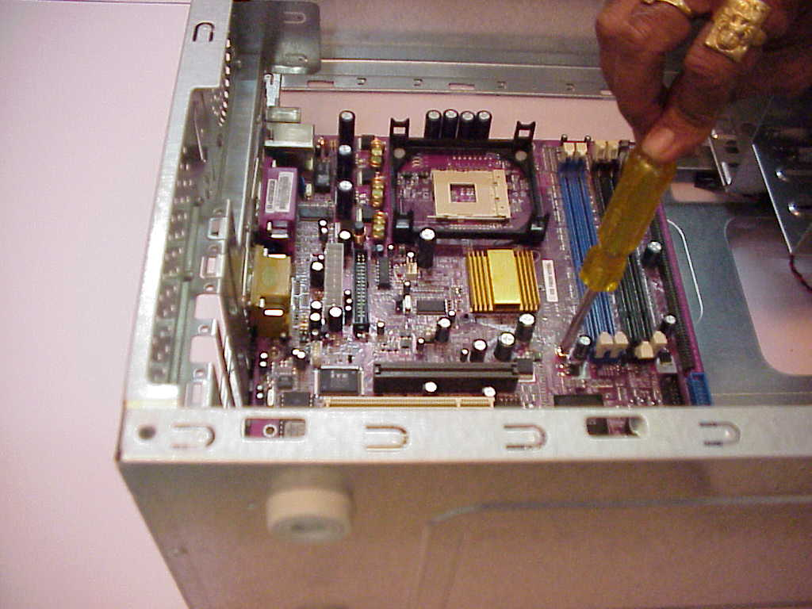

- Step5: Case wiring (front panel ports) connect various wires like those power led, Keys which restart switch, HDD led, Turbo switch and etc. to corresponding motherboard positions.

- Step6: Install the power supply (install SMPS)

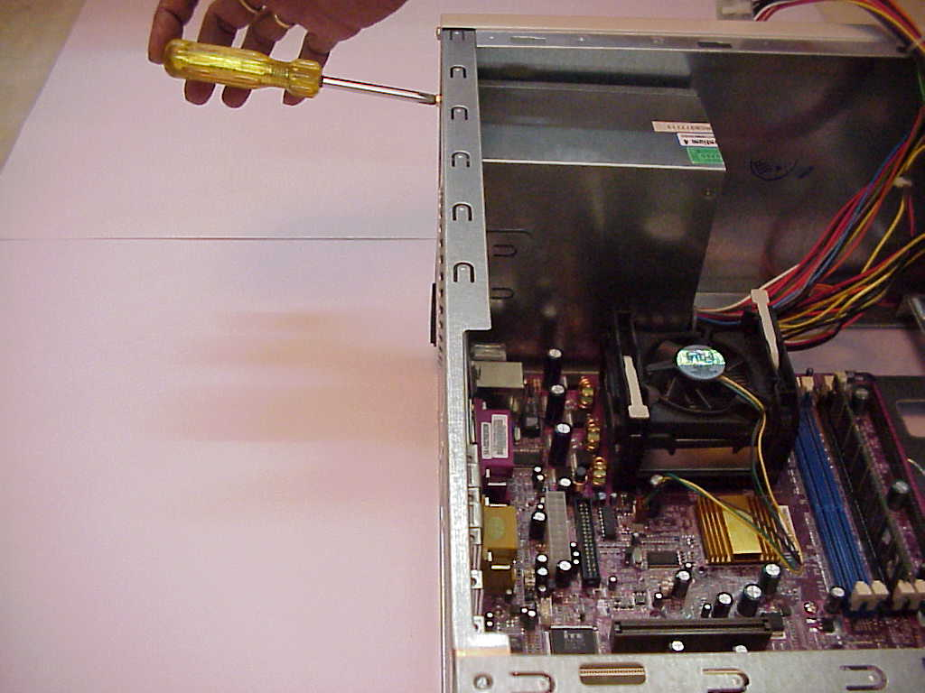

- Step7: Hard disk drive system installation. As Motherboard already provides a aide HDD controller, simply connect hard disk drive to this controller, and enable controller. Take HDD cable of 40 Pins and attach correct and to the 40 pin HDD header on the Motherboard
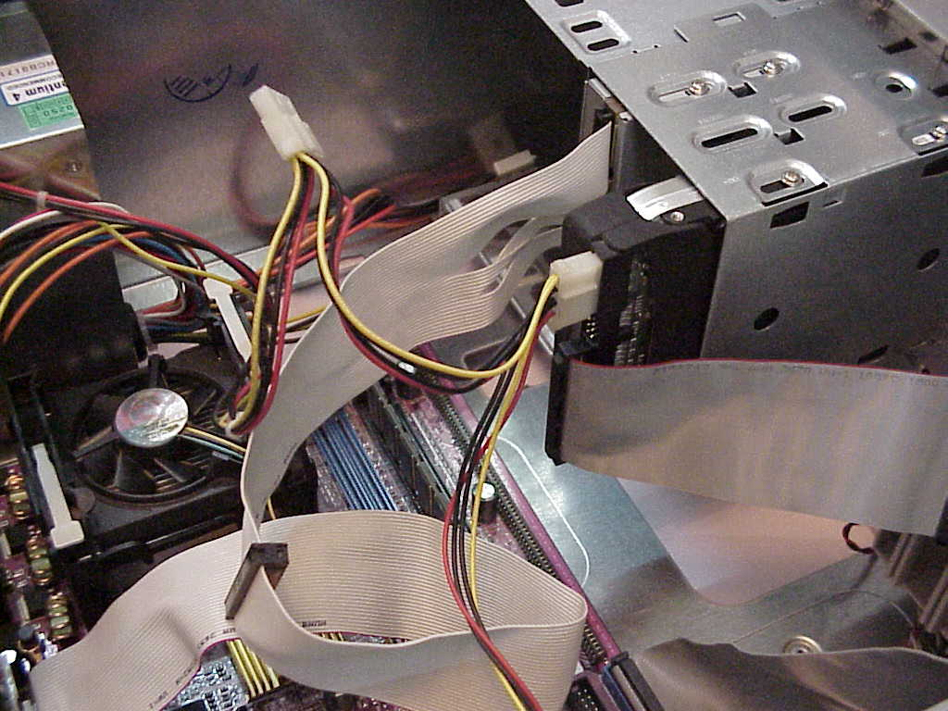

- Step8: CD-ROM Drive:
- Installing on IDE (Integrated Development Environments) secondary channel of the controller. Explain connections pin alignments, master slave combination.
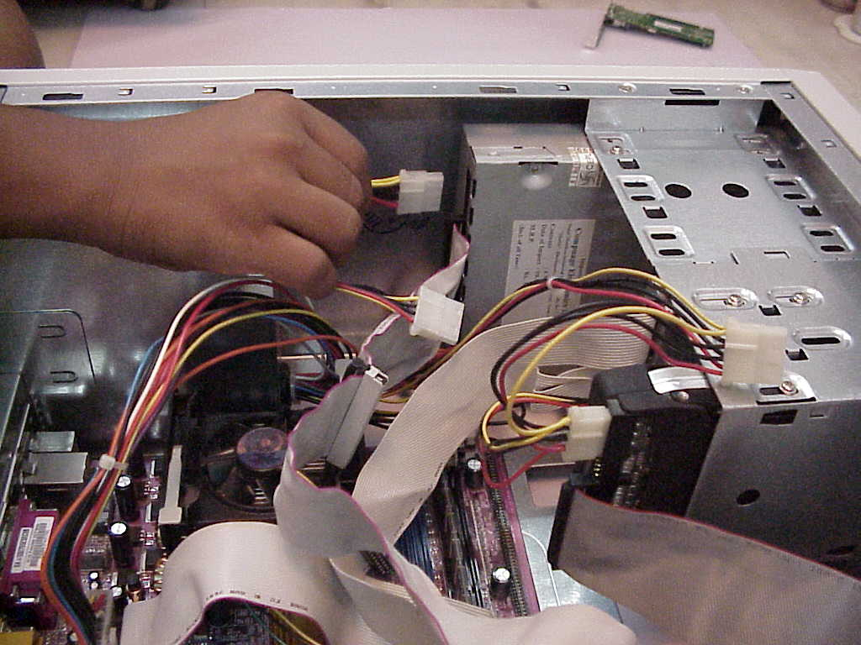

- Step9:Floppy drive installation
- If controller already is motherboard, don’t install a new controller, simply connect the floppy drive cable to an attach the controller. End to the 34 pin floppy drive disk (FDD) Header on the motherboard (take care of pins Alignments)
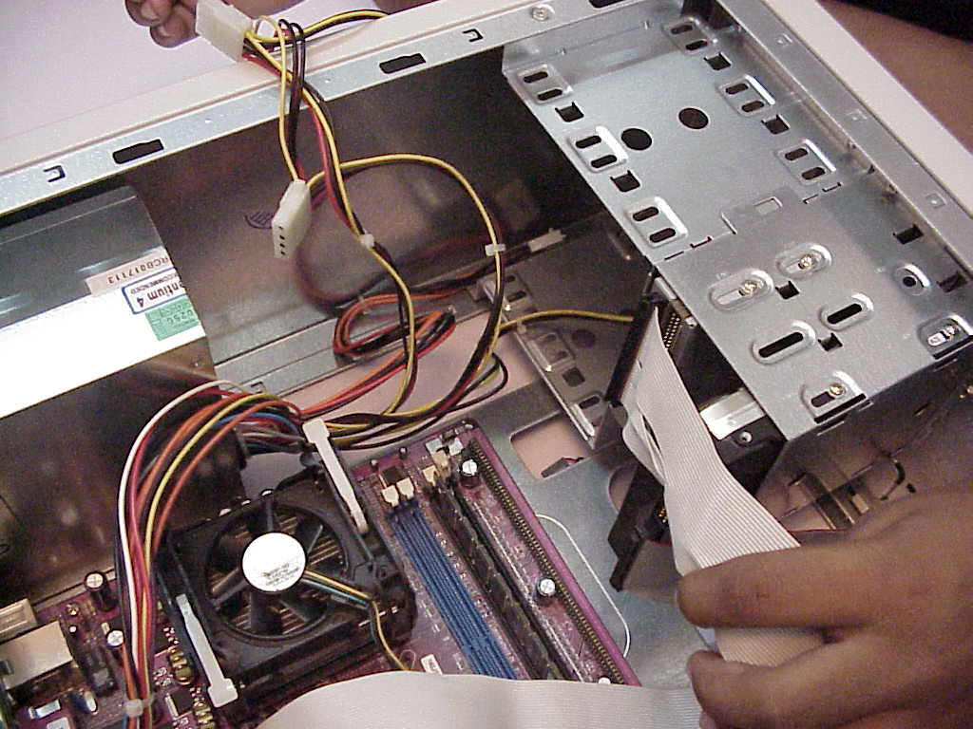

- Step10:Sound board Installation:
- Installing an audio card, which use different interrupts .IVO address and one DMA channel(Direct memory access). Beware of hard complies plug and plug type to do automatically other jumper settings like MIDI and game board setting.

- Step11:System precaution:
- Before closing things up, check whether all Hardware is physically, properly installed and connected before installing on hard disk, check the following.
- Securing of motherboard , expansion boards and etc., no louse screws.
- Check proper seating of expansion cards no interference with CPU RAM Chips.
- Routing properly , Ribbon cables etc.. always from heat of supply , Fans, Video ports.

- Step12: Back up the CMOS
- If motherboard has a video port already attached. Connect monitor to this port , enable video controllers, loading monitor drivers, choosing resolution.

- Step13:Keyboard Installation
- Attach the keyboard cable to the corresponding port in the case. This port would be connected to motherboard.

- Step14:Install the Mouse
- If there is a serial port to connect attach cable to proper connectors.
- Explain difference with PS/2 mouse and adaptor
- Explain bus mouse and how it is configured in open ISA slot.

- Step15:Burn in Test
Check component Failures by keeping devices and PC powered on long periods after it is completely and successfully assembled.

- Step16:Step Button Up
- When all hardware components installed and connected, PC Powered on and everything working properly than close the outer casing and bolt it

Week 2:
Install computer with dual boot operating system (Windows, Linux with PowerPoint presentation). Comparison of types of OS in different platform
- Installation of Windows 7 Operating System
Step 1: Turn your computer on then press Del or F2 (depend on your computer’s mainboard) to enter the system BIOS
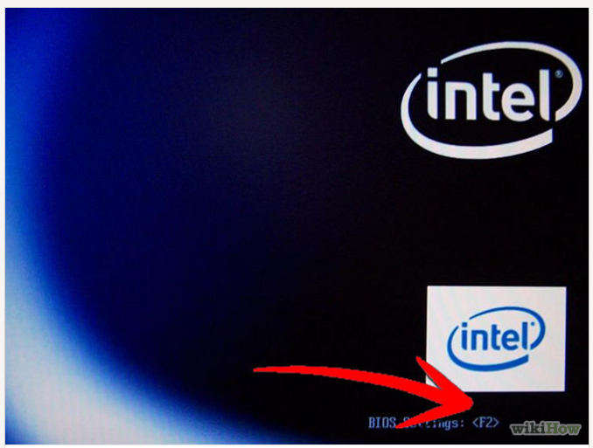
Step 2: Go to Boot menu and choose Boot from CD/DVD.
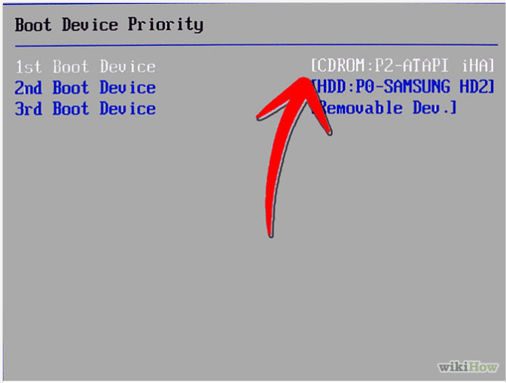
Step 3: Press F10 to save the configuration and exit BIOS then reset your computer.
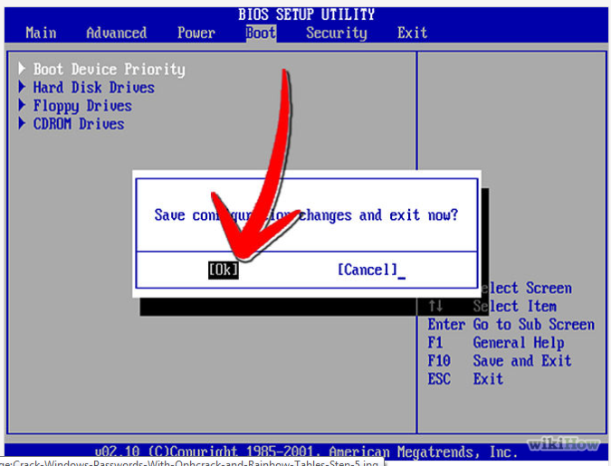
Step 4: Insert Windows 7 DVD into your DVD drive then start up your computer, Windows 7 will be loading files.
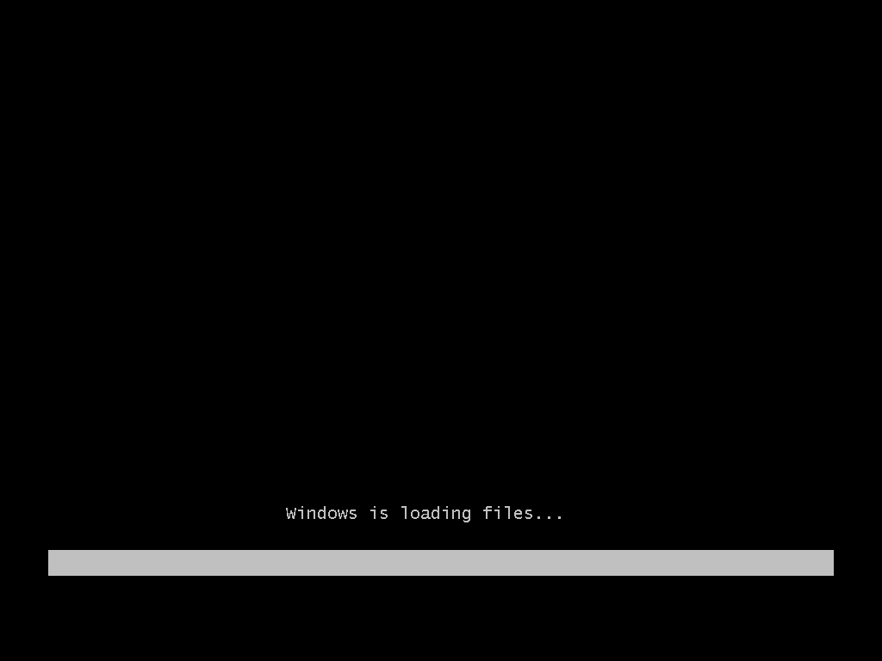
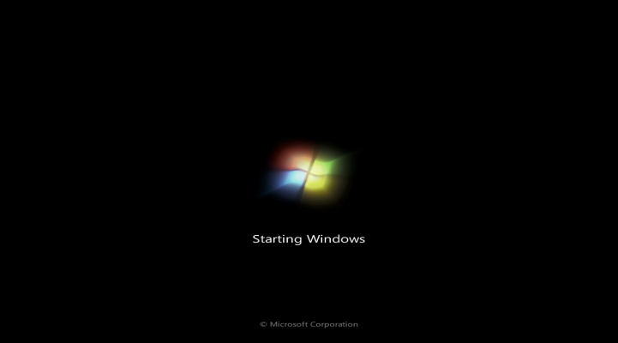
Step 5: Select these parts: Language to Install, Time and currency format, Keyboard or input method. Then click next.
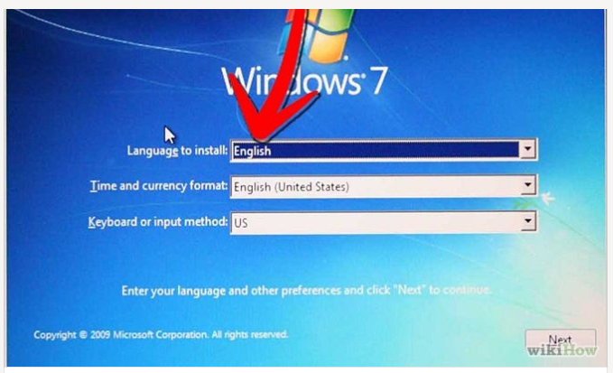
Step 6: Choose Install now if you want to install Windows 7. Choose the Windows 7 version that you want to install in 'Select the operating system you want to install’. Here we choose Windows 7 Ultimate then click next (depending on your Windows DVD, this step is an option).
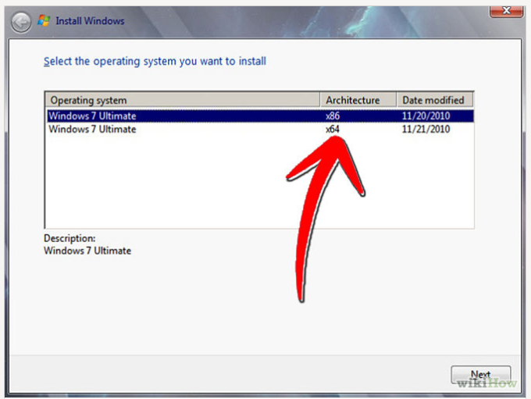
STEP 7: Click 'I accept the license terms' in 'Please read the license' then click Next.
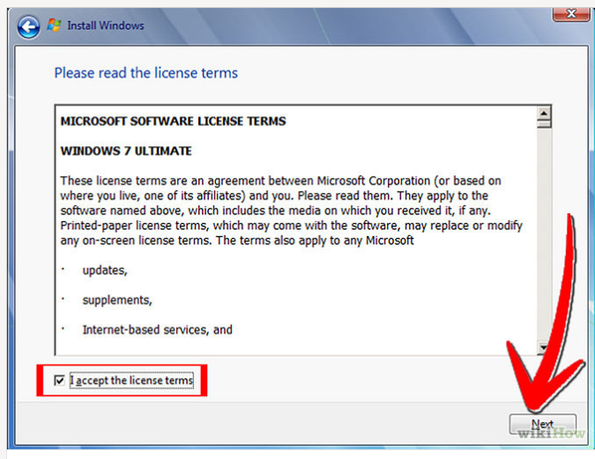
Step 8: Choose 'Upgrade' in 'Which type of installation do you want' if you want to upgrade from an older Windows version to Windows 7, 'Custom (advance)' if you want to install a new version of Windows.
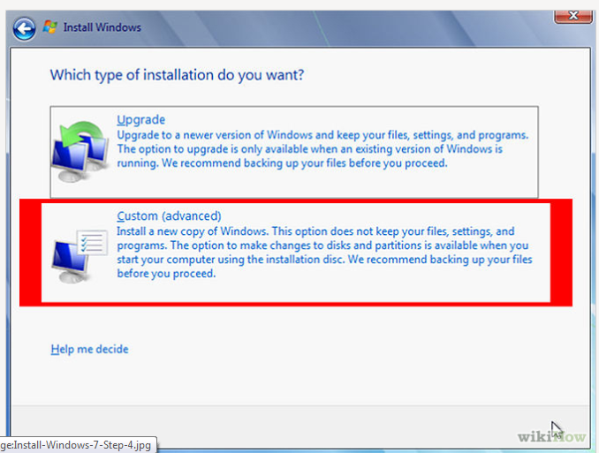
Step 9: Choose Partition for installation, if your computer has only one hard disk, it will be easy for selection, but if it has some Partition, you will have to consider which Partition to choose.
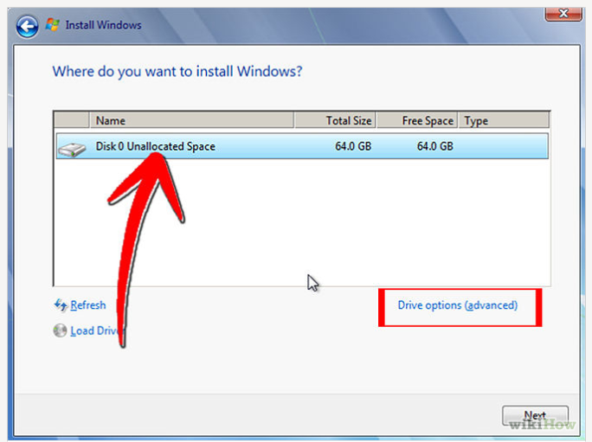

Step 10: Wait for Installing Windows to progress. Your computer might be restarted during the process.
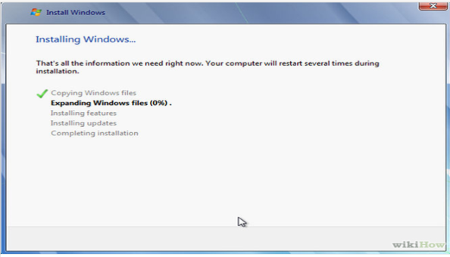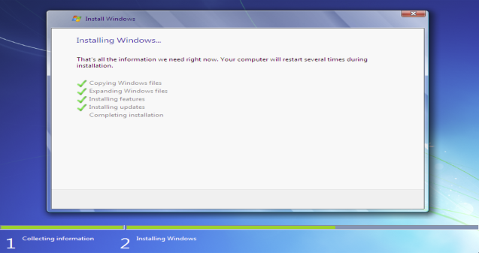
Step11: The third and fourth step will also complete instantly like the first step. After that it will automatically restart after 15 seconds and continue the setup. You can also click Restart now to restart without any delays.
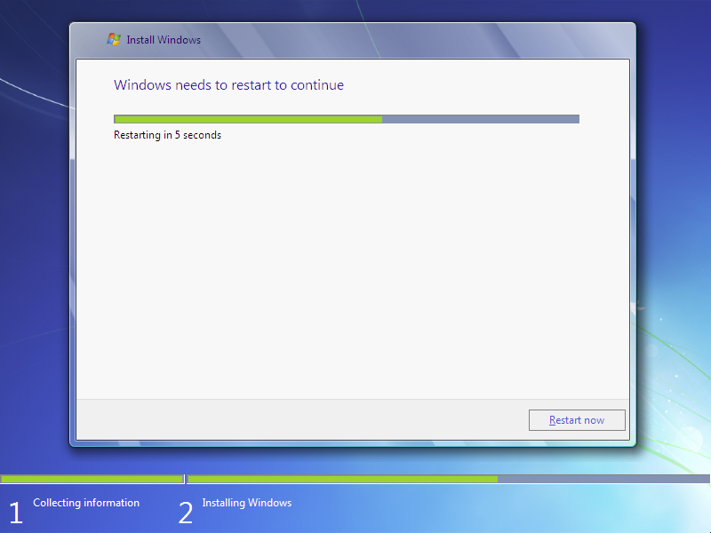
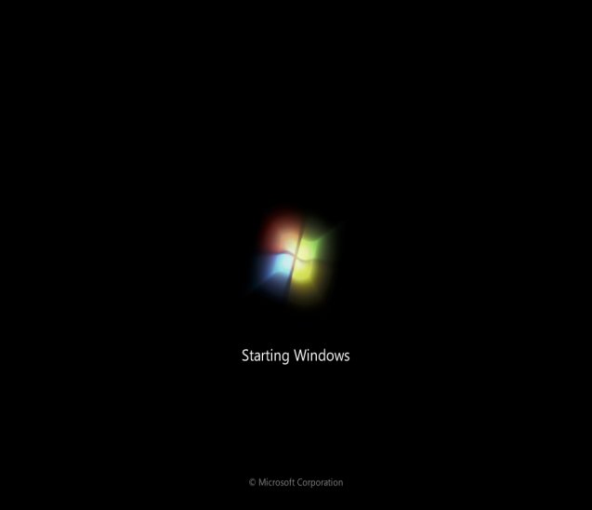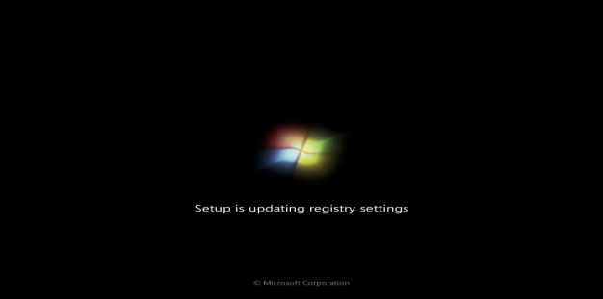
Step 12: After restarting for the first time, it will continue the setup. This is the last step so it will take the most time than the previous steps.
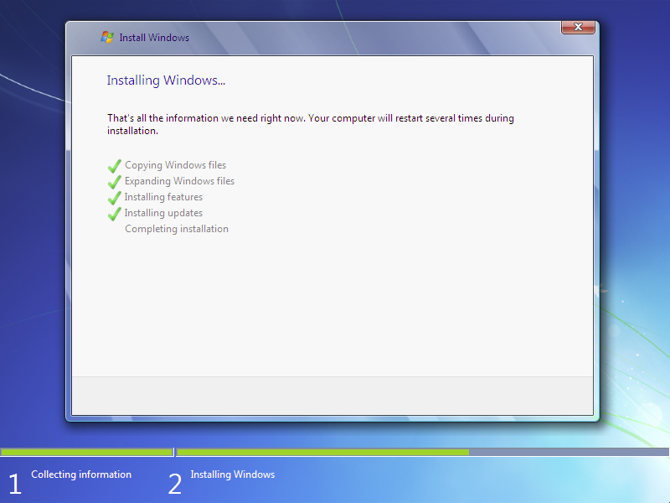

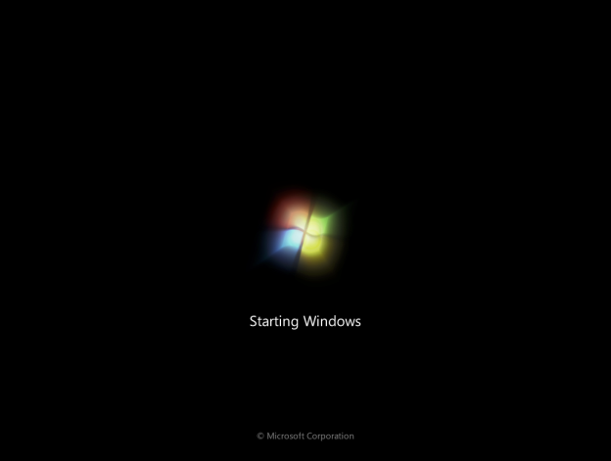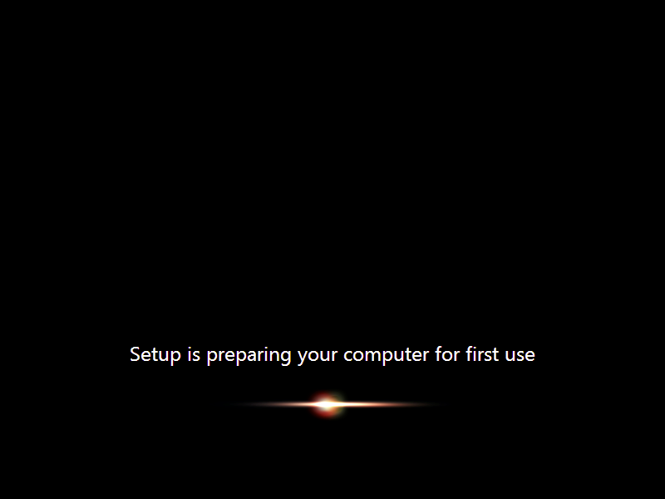
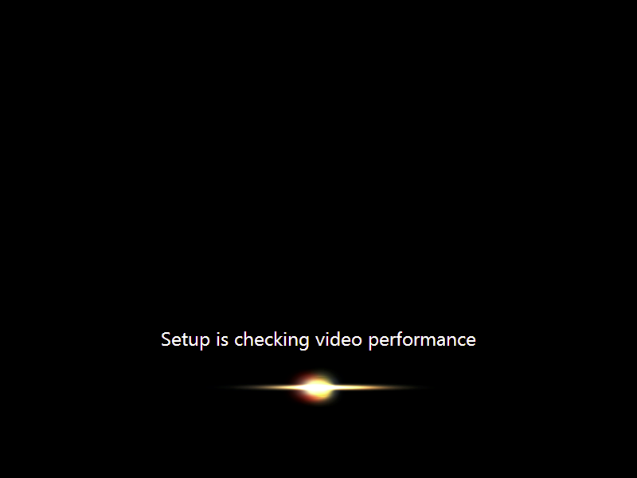
Type your desired user name in the text-box and click Next. It will automatically fill up the computer name.
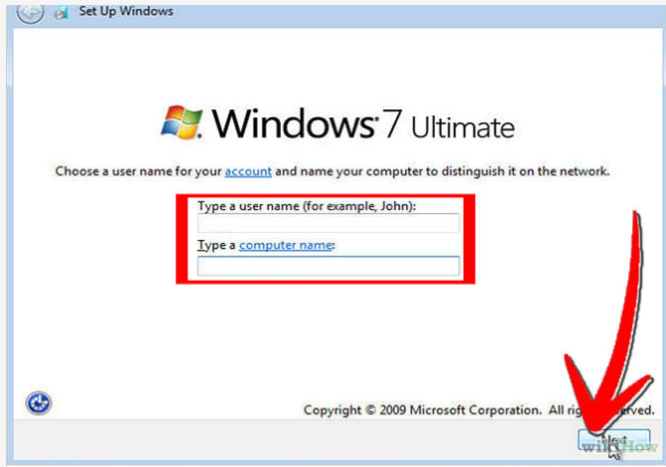
Step12: If you want to set a password, Type a password for your account, you can also Type a password hint to help in case of forgetting the password in the future, and then click Next.
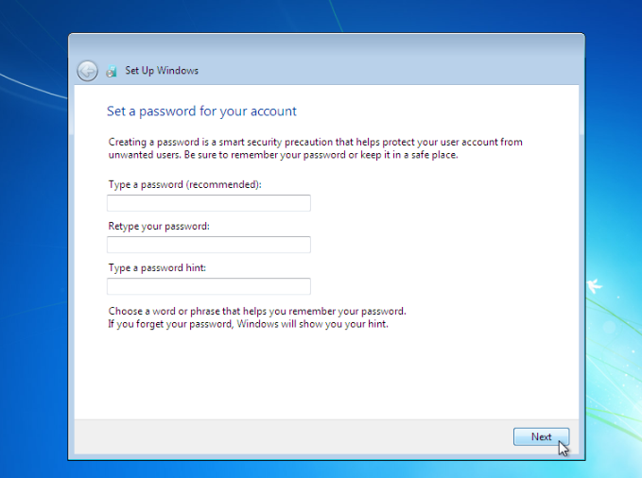
Step13: Type in activation code or key for your license in Product key box if you have any. Click Next.
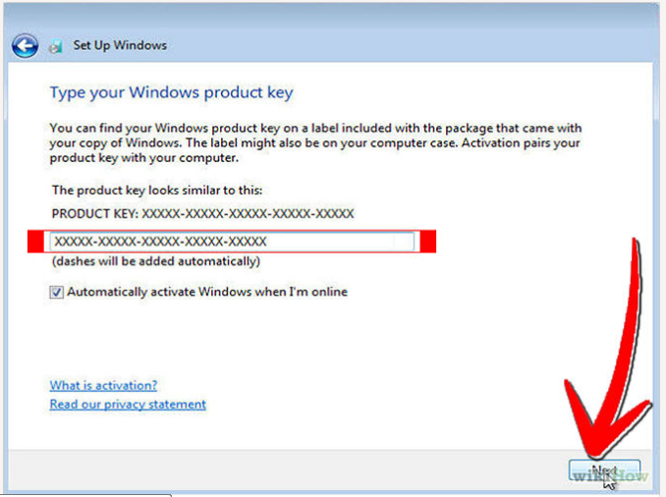
Step14: Choose how to protect your Windows. Here we choose Use recommended settings.
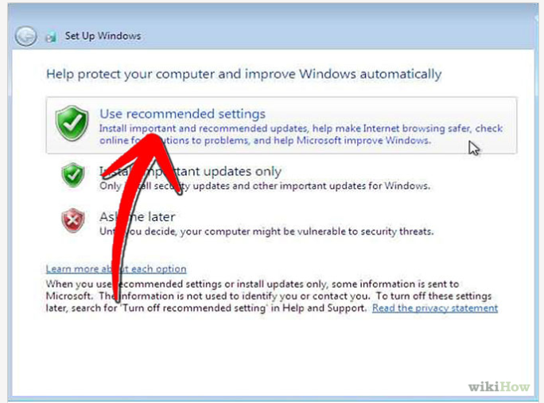

Step15: Set up your Time zone then click Next.
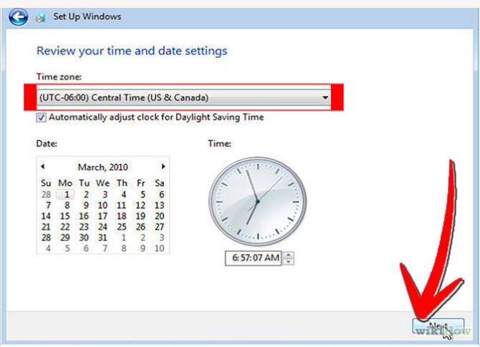
Step16: If you are connected to any network, it will ask you to set the network's location.Choose an option from 3 choices: Public Network, Work Network, and Home Network. Choose Home Network for using Internet at home 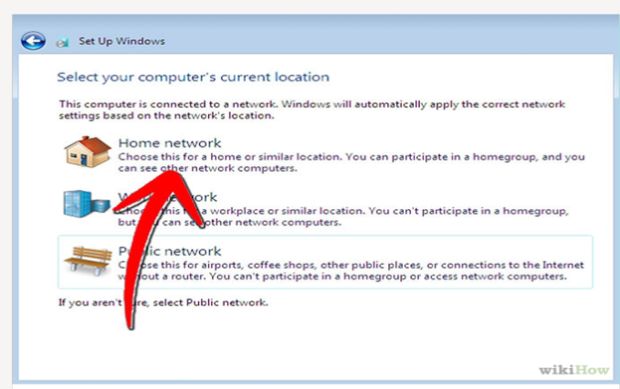
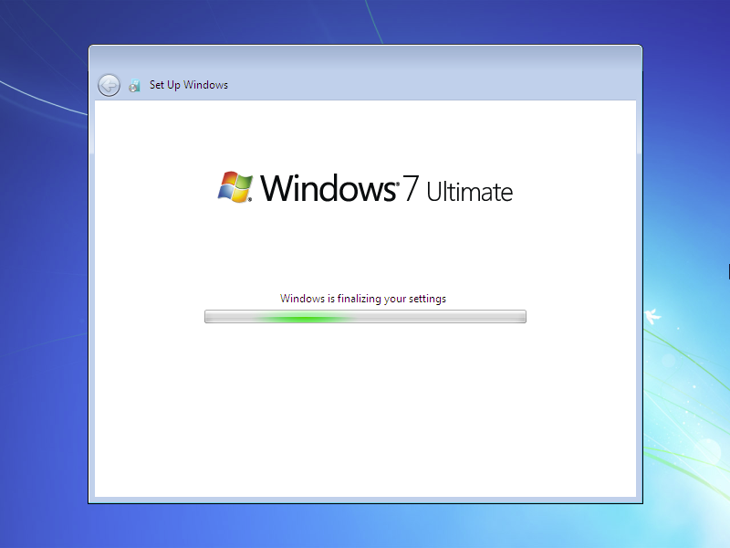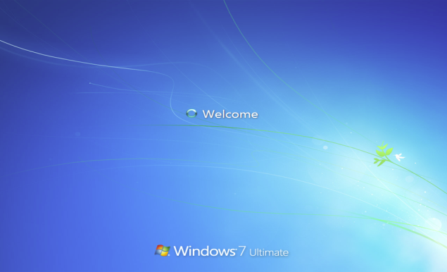
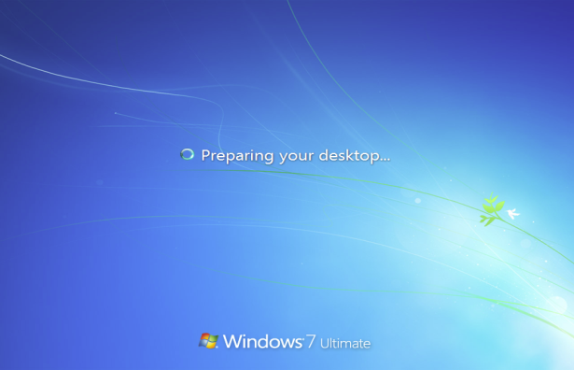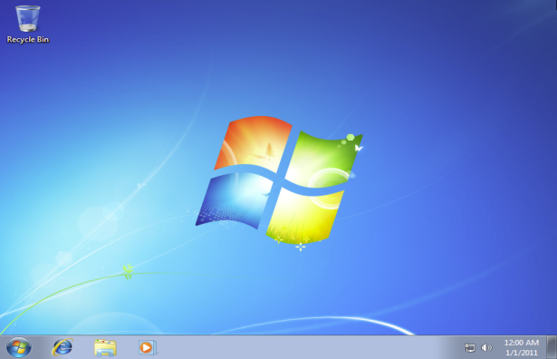

Step-by-Step Guide to Install Ubuntu 18.04 LTS on your Laptop or Desktop

Step 1) Download Ubuntu 18.04 LTS ISO File
Please make sure you have the latest version of Ubuntu 18.04 LTS, If not, please download the ISO file from the link her
https://www.ubuntu.com/download/desktop
Since Ubuntu 18.04 LTS only comes in a 64-bit edition, so you can install it on a system that supports 64-bit architecture.

Step 2) Create a Bootable Disk
Once the ISO file is downloaded then next step is to burn the downloaded ISO image into the USB/DVD or flash drive to boot the computer from that drive.
Also make sure you change the boot sequence so that system boots using the bootable CD/DVD or flash drive.

Step 3) Boot from USB/DVD or Flash Drive
Once the system is booted using the bootable disk, you can see the following screen presented before you with options including “Try Ubuntu” and “Install Ubuntu” as shown in the image below,
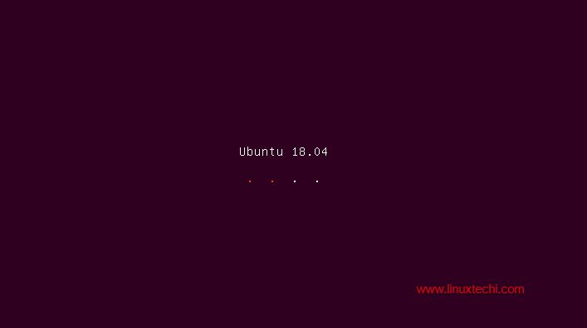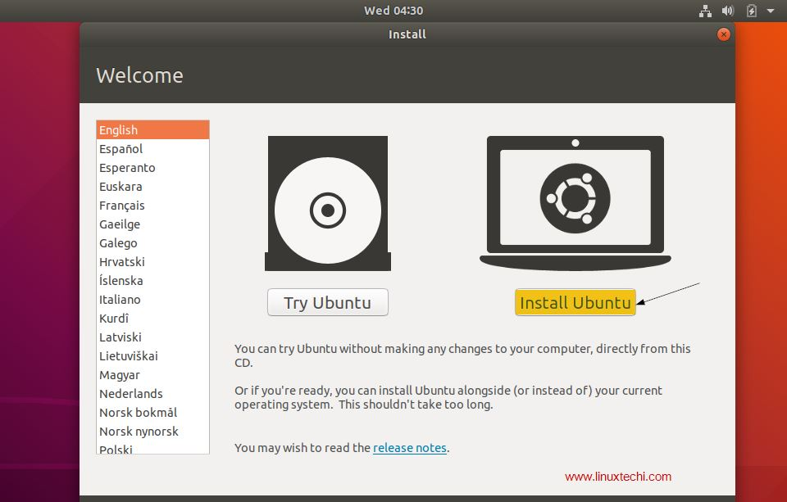
Even though when you click “Try Ubuntu” you can have a sneak peek into the 18.04 LTS without installing it in your system, our goal here is to install Ubuntu 18.04 LTS in your system. So click “Install Ubuntu” to continue with the installation process.

Step 4) Choose your Keyboard layout
Choose your favorite keyboard layout and click “Continue”. By default English (US) keyboard is selected and if you want to change, you can change here and click “Continue”,
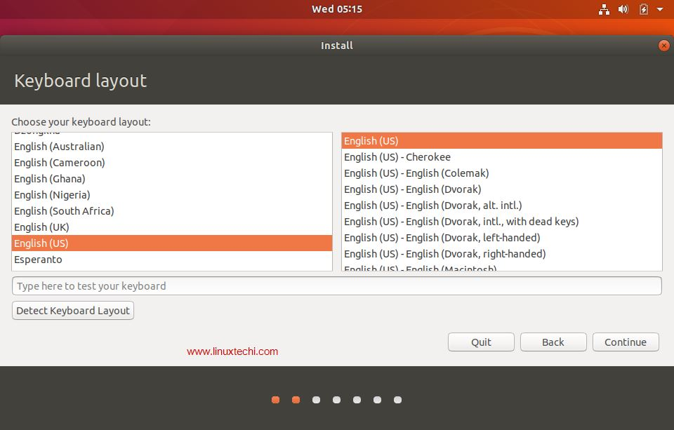

Step 5) Preparing to Install Ubuntu and other Software
In the next screen, you’ll be provided following beneath options including:
- Type of Installation: Normal Installation or Minimal installation, If you want a minimal installation then select second option otherwise go for the Normal Installation. In my case I am doing Normal Installation
- Download Updates While Installing Ubuntu (select this option if your system has internet connectivity during installation)
- Install third party software for graphics and Wi-Fi hardware, MP3 and additional media formats Select this option if your system has internet connectivity)
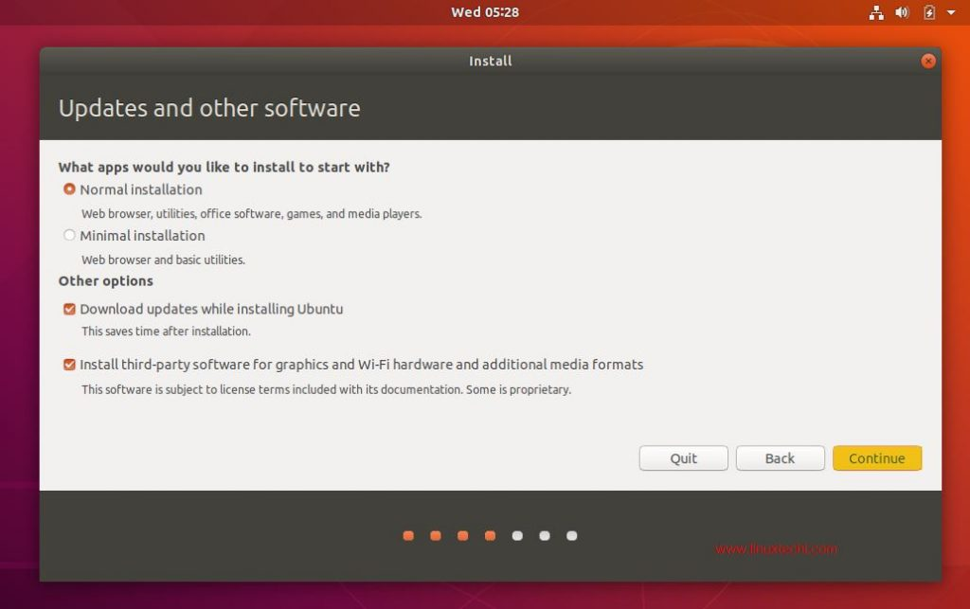
click on “Continue” to proceed with installation

Step 6) Select the appropriate Installation Type
Next the installer presents you with the following installation options including:
- Erase Disk and Install Ubuntu
- Encrypt the new Ubuntu installation for security
- Use LVM with the new Ubuntu installation
- Something Else
Where,
Erase Disk and Install Ubuntu – Choose this option if your system is going to have only Ubuntu and erasing anything other than that is not a problem. This ensures a fresh copy of Ubuntu 18.04 LTS is installed in your system.
Encrypt the new Ubuntu installation for security – Choose this option if you are looking for extended security for your disks as your disks will be completely encrypted. If you are beginner, then it is better not to worry about this option.
Use LVM with the new Ubuntu installation – Choose this option if you want to use LVM based file systems.
Something Else – Choose this option if you are advanced user and you want to manually create your own partitions and want to install Ubuntu along with existing OS (May be Windows or other Linux Flavor)
In this article, we will be creating our custom partitions on a hard disk of 40 GB and the following partitions are to be created:
- /boot 1 GB (ext4 files system)
- /home 18 GB (ext4 file system)
- / 12 GB (ext4 file system)
- /var 6 GB (ext4 file system)
- Swap 2 GB
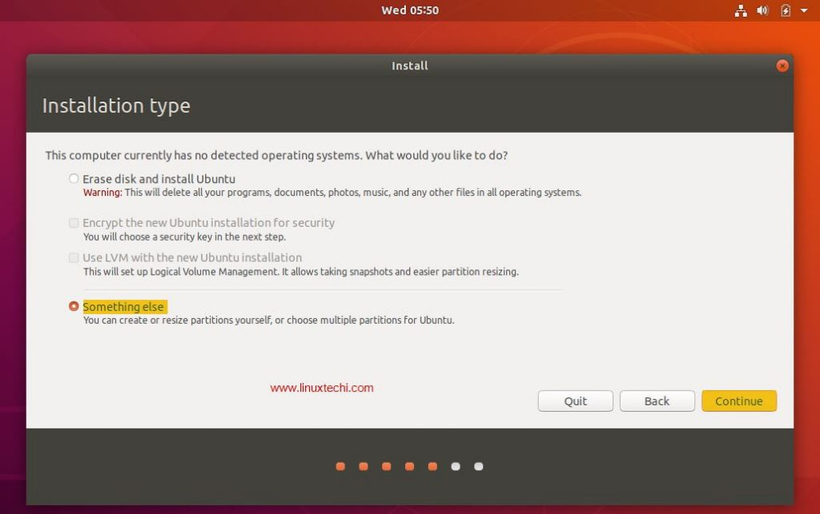
Now, Choose “Something Else” and Click on continue
You can see the available disk size for Ubuntu in the next window as shown below:
Now in order to create your own partitions, click on “New Partition Table”
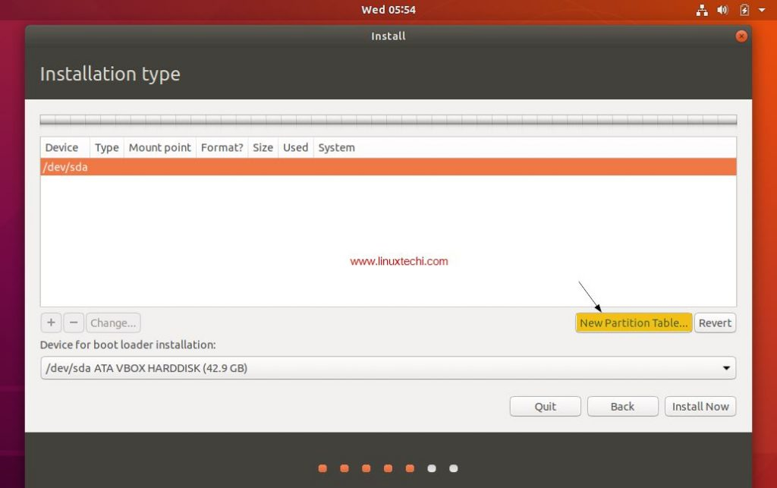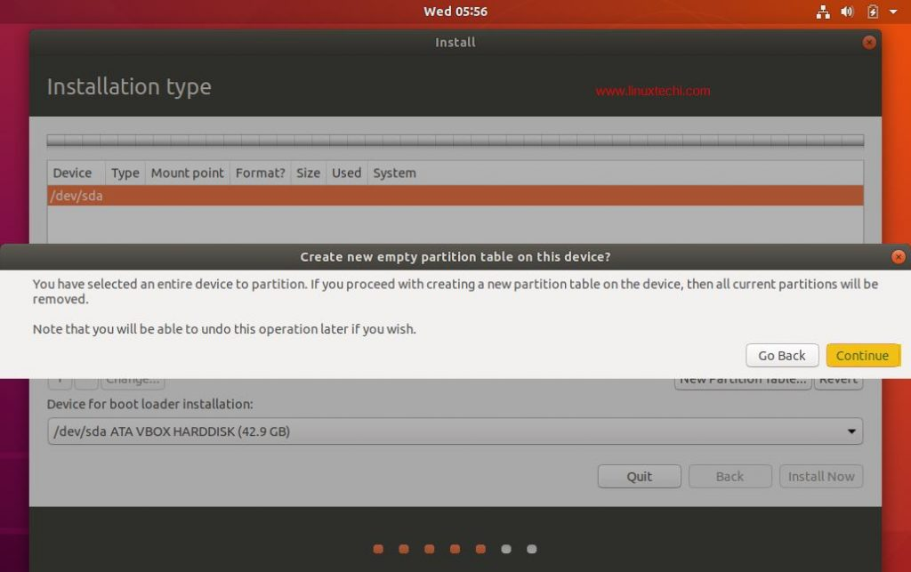
Click on Continue
Create /boot partition of size 1GB, Select the free space and then Click on the “+” symbol to create a new partition
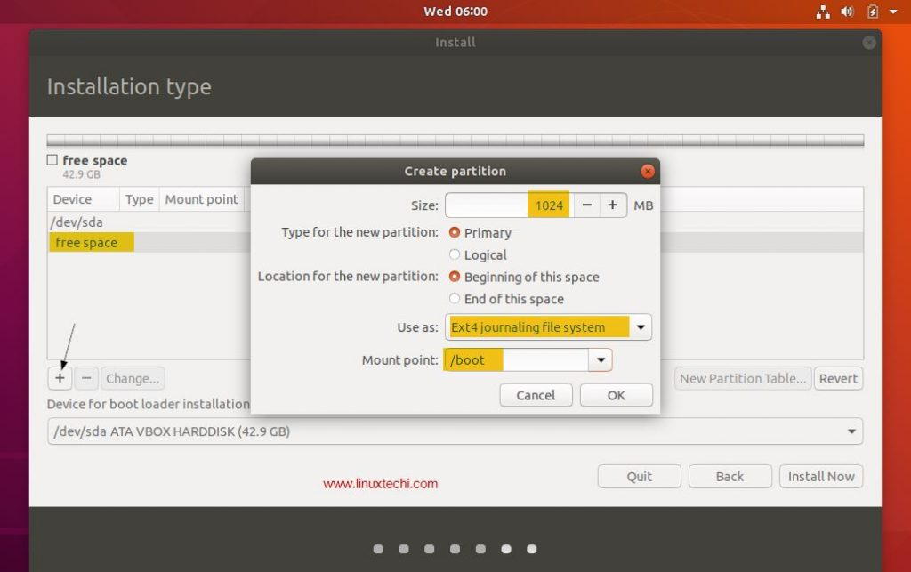
Click on “OK”
Let’s create /home partition of size 18 GB,
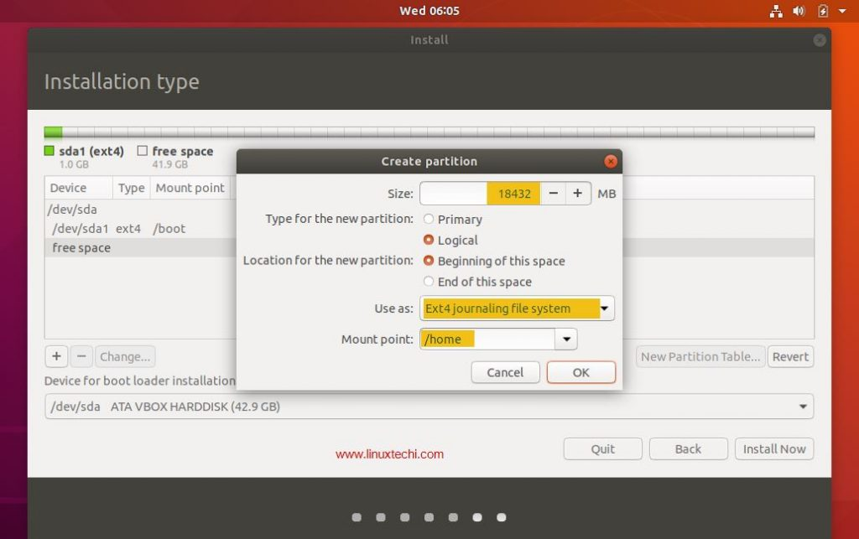
In the same way create / & /var file system of size 12 GB & 6 GB respectively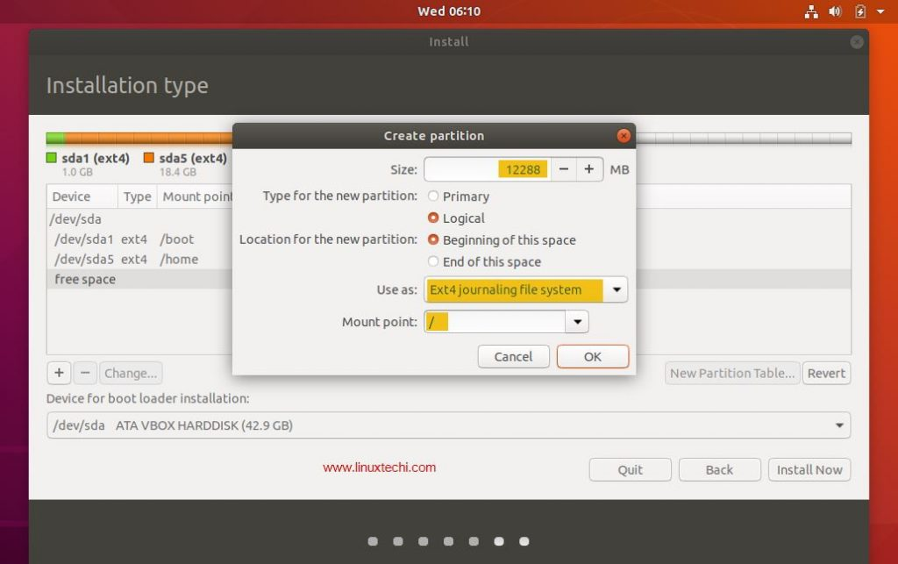 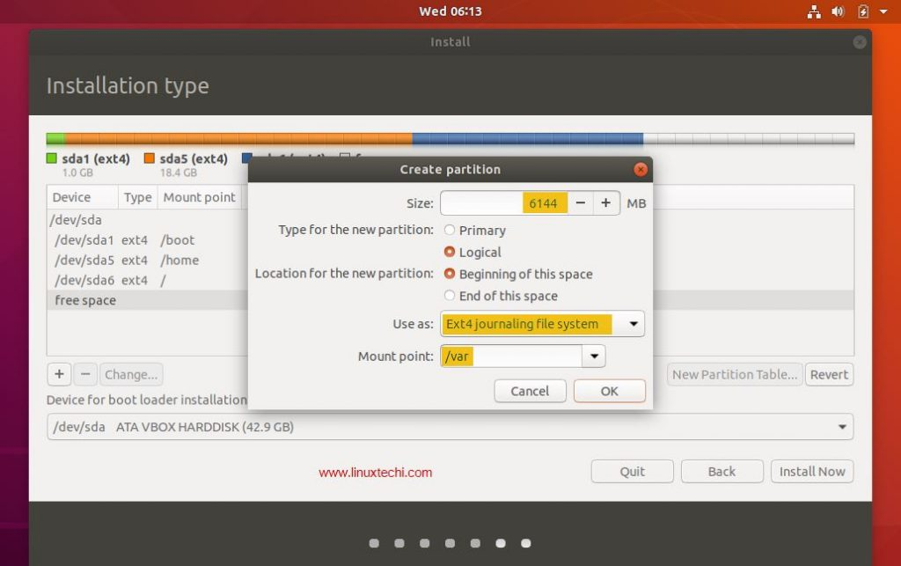
Now create last partition as swap of size 2 GB,
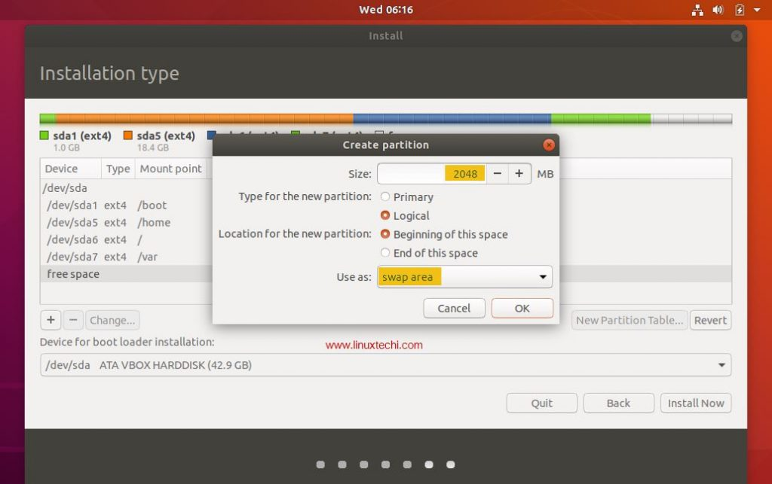
Click on OK
Once you are done with the partition creation task , then click on “Install Now” option to proceed with the installation
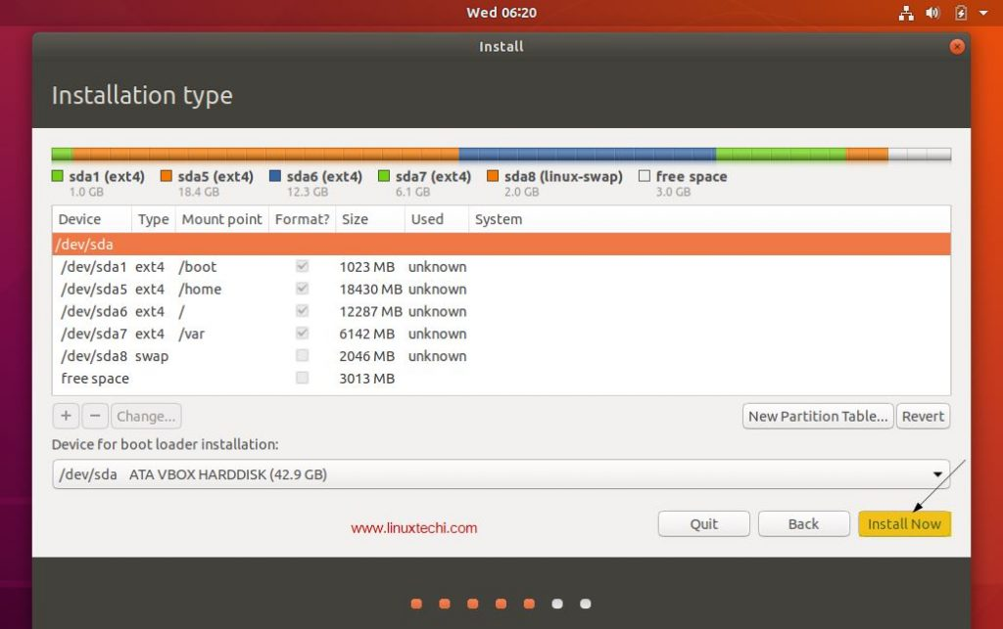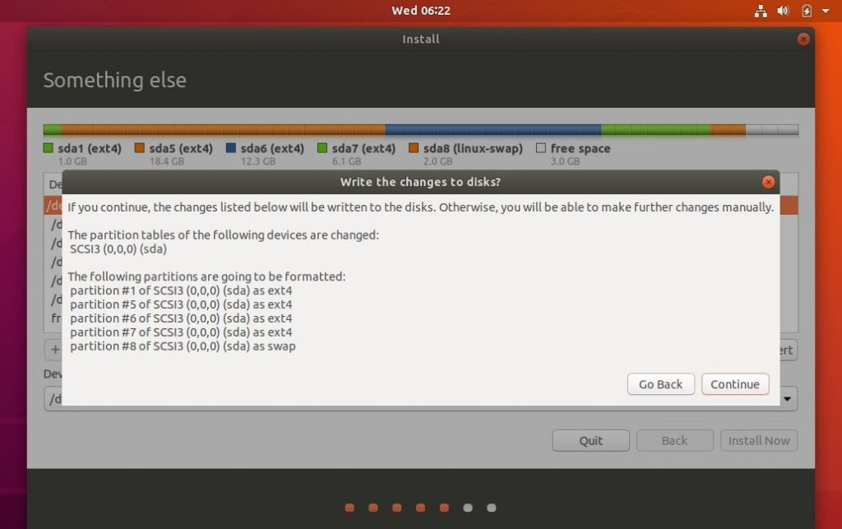
Now click on “Continue” to write all the changes to the disks

Step 7) Select Your Time zone
Choose your favorite time zone and then click on “Continue”
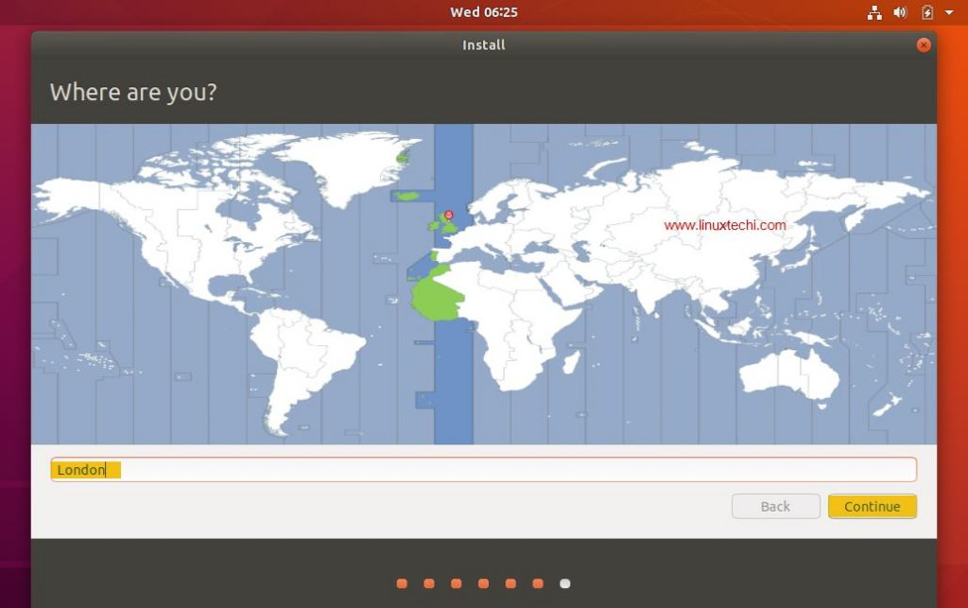

Step 8) Provide your User Credentials
In the next screen you will be prompted to provide your user credentials. In this screen provide your name, computer name, username and the password to login into Ubuntu 18.04 LTS
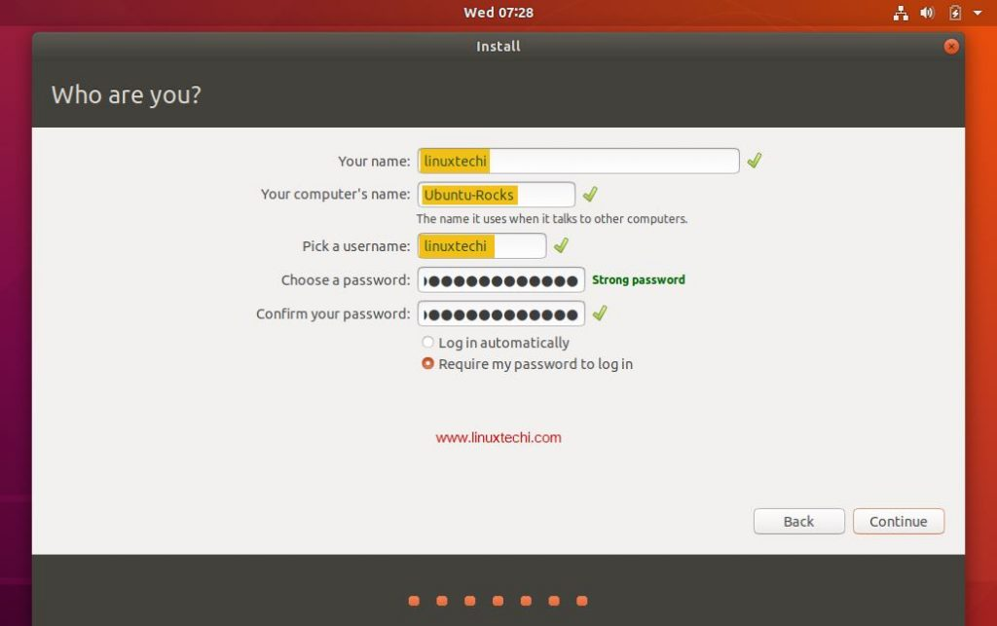
Click “Continue” to begin the installation process.

Step 9) Start Installing Ubuntu 18.04 LTS
The installation of Ubuntu 18.04 LTS starts now and will take around 5-10 mins depending on the speed of your computer,
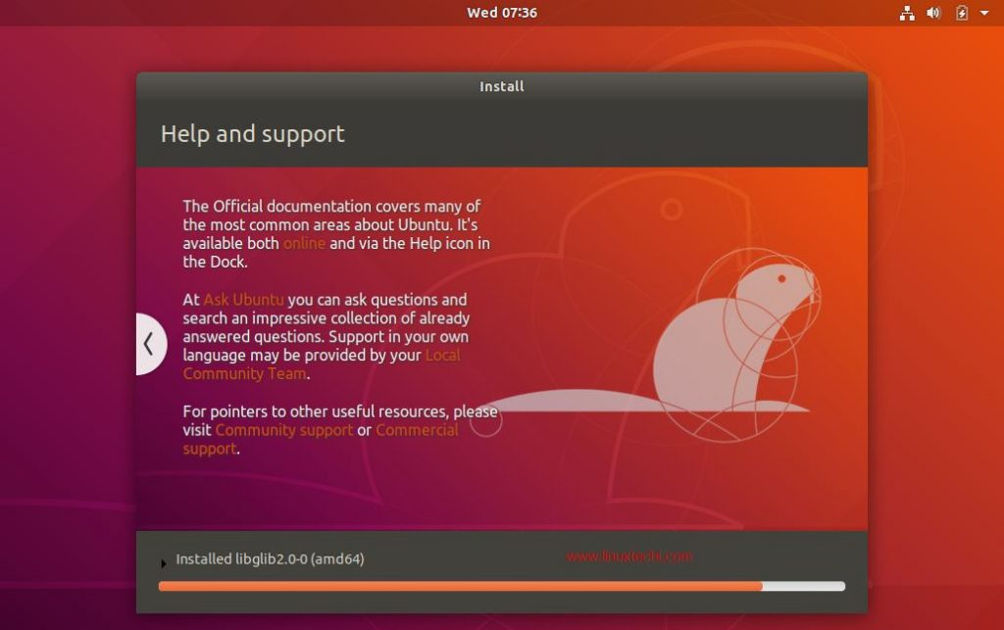

Step 10) Restart Your System
Once the installation is completed, remove the USB/DVD from the drive and Click “Restart Now” to restart your system.
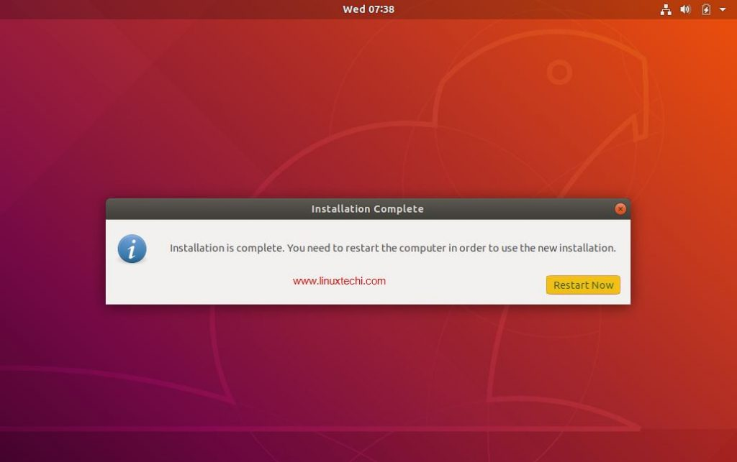

Step:11) Login to Your Ubuntu 18.04 desktop
Once your system has been rebooted after the installation then you will get the beneath login screen, enter the User name and password that you have set during installation (Step 8)
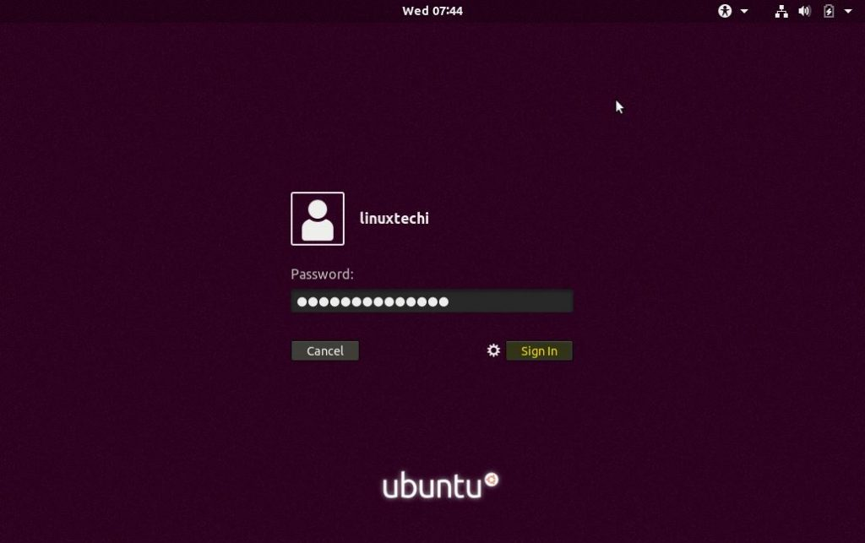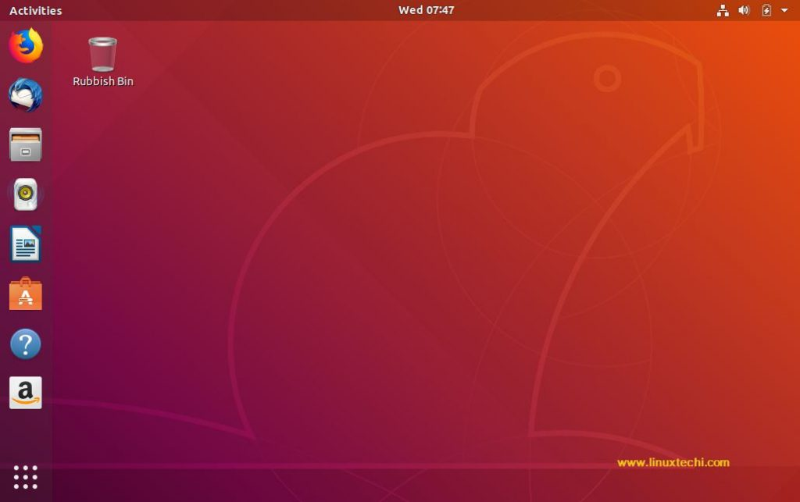
And that concludes our step by step installation guide for Ubuntu 18.04 LTS and it’s all up to you now to explore the exciting features of Ubuntu 18.04 LTS and have fun
Viva Questions:
- NTFS stands for---------?
- What is the use of product key in the installation process of a software?
- How many characters does a product key contain fro windows XP?
- Describe different kinds of Microsoft Operating systems?
- What are the pre-arrangements for installing the windows OS?
- Give the advantages of Linux over other OS?
- What do you mean by open source OS?
- What are the commands used to make disk partitioning manually in Linux OS?
- What do you mean by dual boot systems?
- Which type of file systems are required to install hard disk at the time of installation of Linux OS?

Week3:
Difference between Hardware and Software
- Hardware
It refers to any physical component of computer. Hardware is the part of the computer that we can touch and feel. It is made up of interconnected electronic devices that control the operations of the computer.
A computer system has the following hardware components:
Motherboard, Input Devices, Output Devices, Storage Devices, Cards, Ports and Cords, Power Supply, Processor, Memory.
- Software
It refers to the programs to run the computer. Software is a group of instructions that tell the hardware what to do. These instructions are also called ‘programs’.
Ex: Ms Outlook Express, ASP, VB, Java, MS Office etc.
- Microsoft Office and its Tools
Office Tools is a set of several tools like Word, Excel, and PowerPoint etc.
- MS Word -> used for word processing
- MS Excel -> used for calculation and analysis of data
- MS PowerPoint -> used for business and technical presentations

- Introduction to word processing
A word processor is a program that enables you to create, edit and print documents. To perform word processing, you need a computer, the word processing software and a printer. A word processor enables you to create a document, store it electronically on a disk, display it on screen, modify it by entering commands and characters from the keyword and print it on a printer.
The greatest advantage of word processing over using a type writer is the cases with which you can make changes with out retyping the entire document .if you want to delete a paragraph erase it, without leaving a trace .it is equally easy to insert a word insert a word, sentence or a paragraph in the middle of a document .word processors also allow you to move sections of text from one palace to another within document, or
Between documents .when you have all the changes you want, you can send the file to a printer to get a hard copy.
- BASIC FEATURES

Word processors vary considerable, but all word processors support the following basic features:
Insert text: allow you to insert text anywhere in the document.
Delete text: Allows you to erase characters, words, lines or pages easily.
Cut and paste: Cut and paste allows you to remove (cut) a section of text from one place in a document and insert (paste) it somewhere else. To cut means to remove an object from a document and place it in a buffer. In word processing for example cut means to move a section of text from a document to a temporary buffer. This is one way to delete text. However, because the text is transferred to a buffer, it is not lost forever. You can copy the buffer somewhere else in the document or in another document, which is called pasting. To move a section of text from one place to another, therefore, you need to first cut and then paste it. This is often called cut and paste.
Copy: Allows you to duplicate a section of the text. When you copy a piece of data, it is moved to temporary location. In word processing, for example, copying refers to duplicating a section of document and placing it in a buffer (called a clipboard).the term copy differs from cut, which refers to actually removing a section of a document and placing it in a buffer. After cutting or copying, you can move the contents of the buffer by pasting it elsewhere.
Page size and margins: allows you to define various page sizes and margins and the word processor will automatically readjust the text so that it fits.
Search and replace: this is a feature supported by most word processor which lets you replace a character string (a series of characters) with another string whenever the former appears in the document .Most word processors have two searches and replace modes. In the first mode the word processor automatically makes all the replacements in the file. In the second mode, the word processor requires you to approve each replacement. This is safer because you may not want to make the change everywhere. Search and replace is sometimes called find and replace.
Print: Allows you to send a document to a printer to get hard copy.
- Starting Microsoft Word 2007
- Two Ways
- On the taskbar, click the Start button, click All Programs, click Microsoft Office,
  - and then click Microsoft Office Word 2007.
  - The Word program window opens, displaying a blank document.
2. Click the Microsoft Office Button.
  - Commands related to managing documents (such as creating, saving, and printing) are available from the menu that opens.
  - This Office menu, takes the place of the File menu that appeared in previous versions of Word
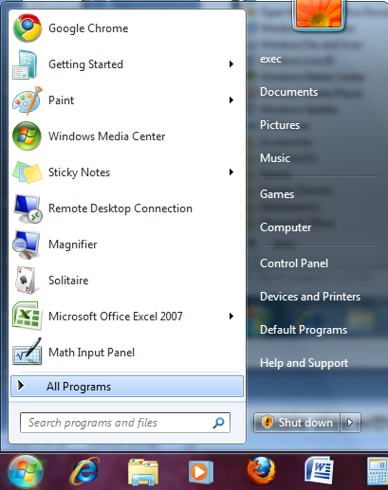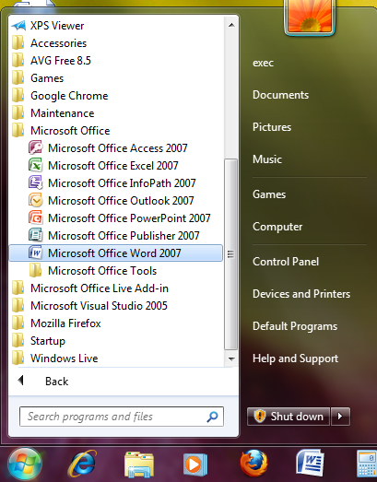
- The Word screen
Introduction
When you start up Word, the initial screen will look something like this:
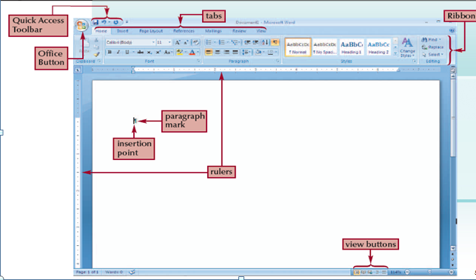
- Selecting Print Layout View
- You can use the View buttons in the lower-right corner of the Word window to change the way your document is displayed
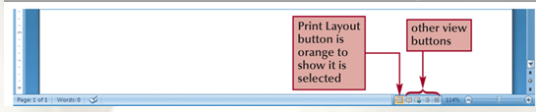
- Displaying the Rulers
- Click the View tab
- In the Show/Hide group, click the Ruler check box to display a checkmark.
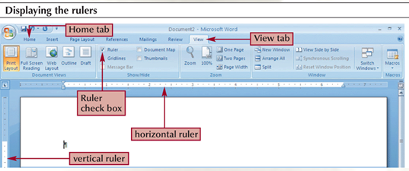
- Checking the Zoom Setting
- Zoom level controls the document’s on-screen magnification
- Setting the Zoom level to Page Width shows the entire width of the document on your screen
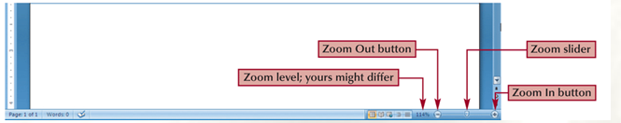
- Saving a Document for the First Time
- Click the Save button on the Quick Access Toolbar
- Type a name in the File name text box
- Click the Save in list arrow, and then select the location where you want to save the file
- Click the Save button at the bottom of the Save As Dialog box
- Using the Undo and Redo Commands
- To undo (or reverse) the last thing you did in a document, you can click the Undo button on the Quick Access Toolbar
- If you want to restore your original change, the Redo button reverses the action of the Undo button (or redoes the undo)
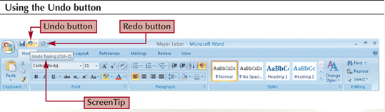
- Understanding Line and Paragraph Spacing
- Line spacing determines the amount of space between lines of text within a paragraph
- Paragraph spacing determines the amount of space before and after a paragraph
- Paragraph spacing is measured in points
- A point is approximately 1⁄72 of an inch
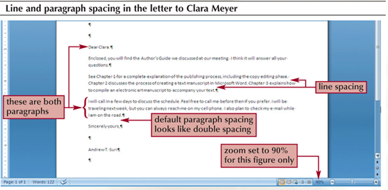

- Adjusting Paragraph and Line Spacing
- The quickest method to adjust paragraph and line spacing is to click the Line spacing button in the Paragraph group on the Home tab
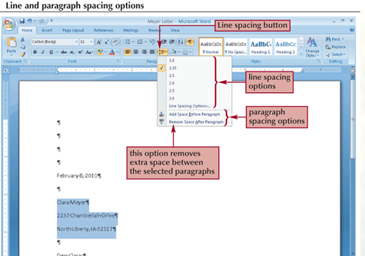
- Add Watermark or a Back Ground
- On the Page Layout tab, in the Page Background group, click Watermark.
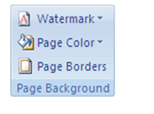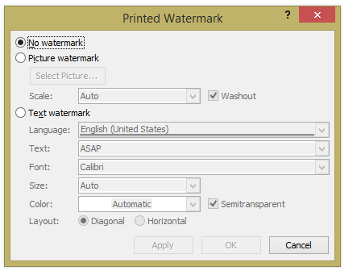
- Then screen shown in the fig. Then select any one option
  - No Watermark
  - Picture watermark
  - Text watermark
- On the Page Layout tab, in the Page Background group, click Page Color.

- Setting Borders
Choose the borders settings. Open the document you wish to add a border to and click the Page Layout tab. Select the Page Borders button, located in the Page Background menu on the toolbar. The Borders and Shading dialogue box will open.
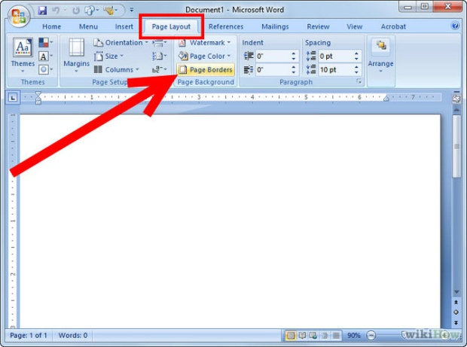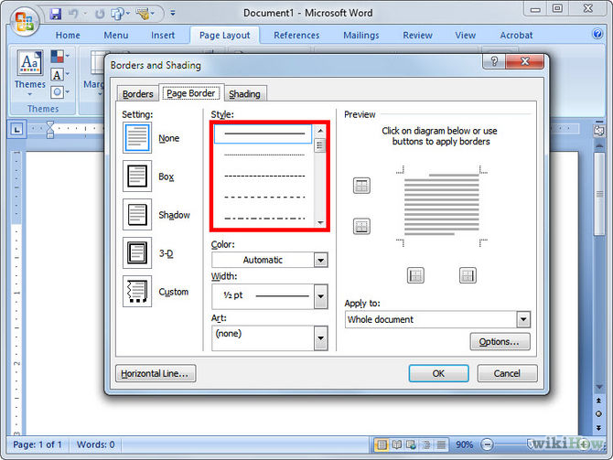
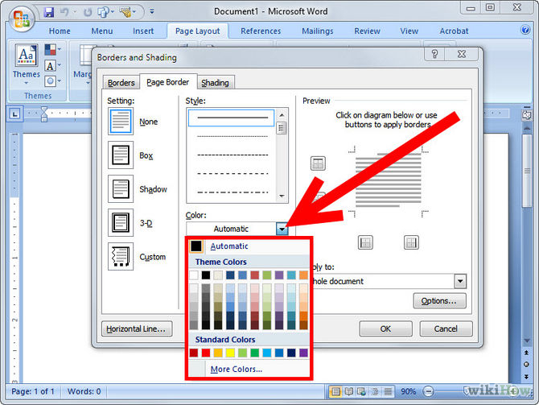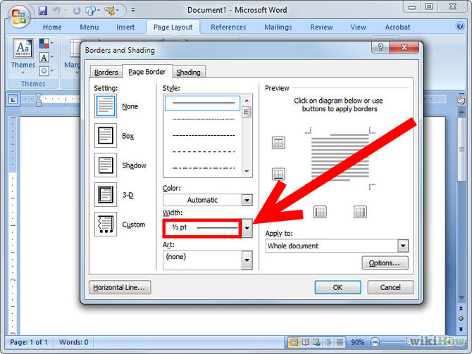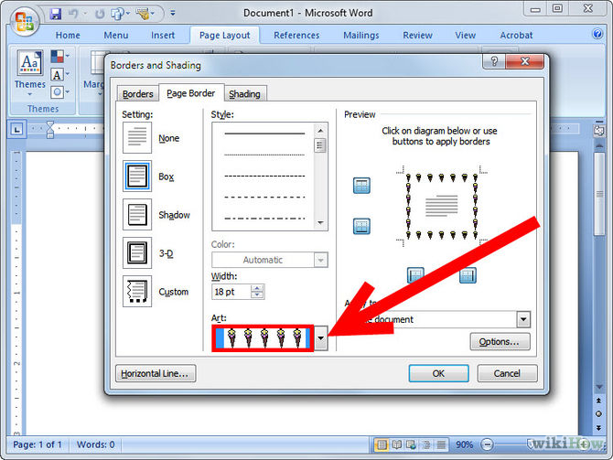
- Fonts
- You can change the look and feel of your document by changing the font size and the font type. You can highlight a particular section or heading by changing the font color and font style.
- To change the font properties for a particular section of text, select the particular text with your mouse. Then click on HOME and select FONT.
- A dialog box opens which will give you the option to change the Font Size, Font Style (Bold, Italic and Underlined), Font (Times New Roman, Verdana etc.) and Font Color.

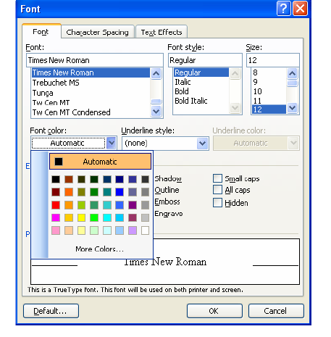
- Single and double spacing
- You can change the spacing between the lines or the spacing before or after each paragraph to make the particular text easily readable.
- All documents are generally single-spaced. If you want to change the spacing on the documents, click on Home tab. In the Home tab, look for the Paragraph section. Click the Line Spacing button to open the Line Spacing dropdown menu. The button has 4 small lines with an arrow pointing both up and down
- The dialog box which appears has a section on Spacing where you select the line spacing as “Single”, “1.5 lines” or “Double” from the drop-down menu.
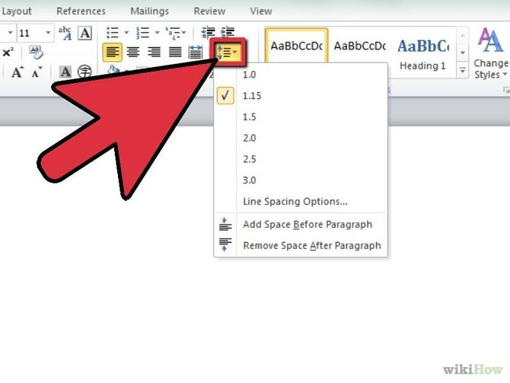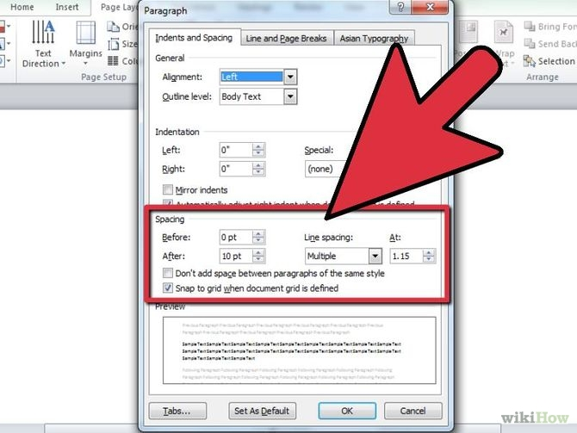
- Cut, Copy and Paste
- Select the segment of text to be cut and click On the Home tab (Message tab in Outlook), in the Clipboard group, click the Clipboard Dialog Box Launcher.
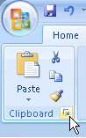
- Tables
- Use
- A table can be filled with text and graphics. Tables are often used to organize and present information.
- How to
- To create a table, click On the Insert tab, in the Tables group, click TABLE. This opens a dialog box where you can specify the number of rows and columns required for the table.
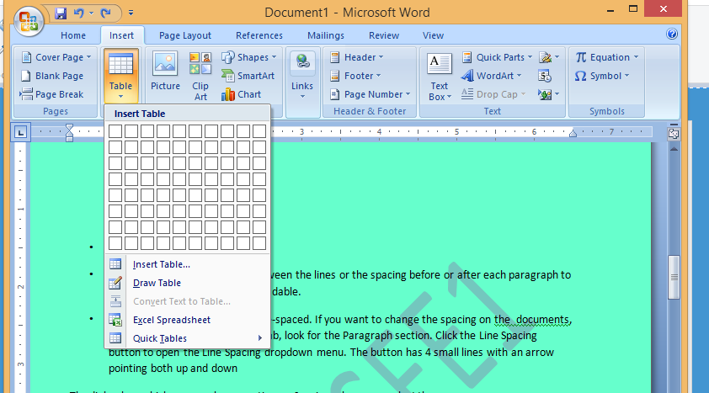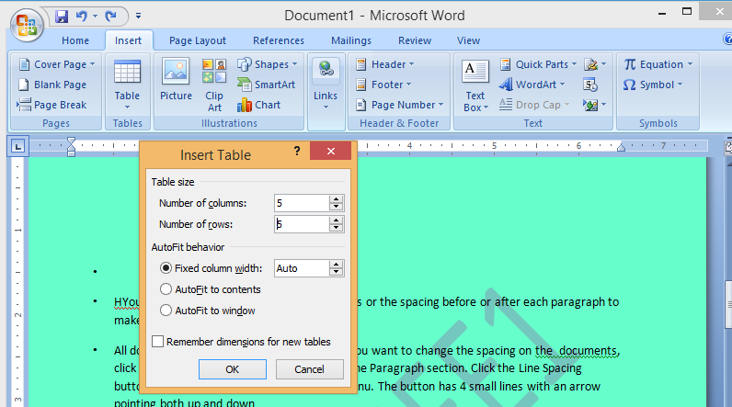
- Lists
- Lists are primarily of two types: bulleted and numbered. Select the items that you want to add bullets or numbering to.
- On the Home tab, in the Paragraph group, click Bullets or Numbering.
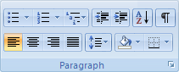
- After selecting the style, click the OK button.
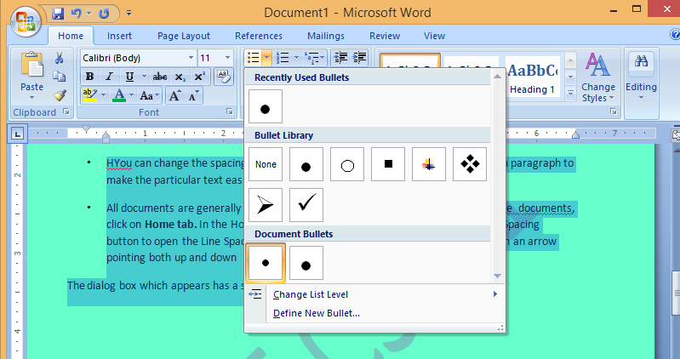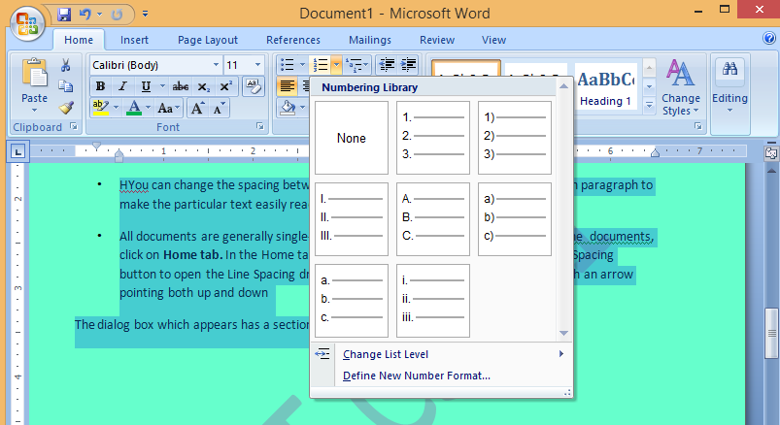
- Headers , Footers and Page numbers
- Headers and footers are areas in the top, bottom, and side margins of each page in a document.
- On the Insert tab, in the Header & Footer group, click Header or Footer.
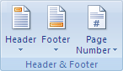
- Click the header or footer design that you want.
The header or footer is inserted on every page of the document
- Inserting a Picture
- On the Insert tab, in the Illustrations group, click Clip Art.
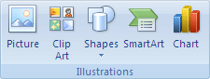
- In the Clip Art task pane, in the Search for text box, type a word or phrase that describes the clip art that you want, or type in all or some of the file name of the clip art.
- Insert a picture from a file
- Click where you want to insert the picture.
- On the Insert tab, in the Illustrations group, click Picture.

- Locate the picture that you want to insert.
- Double-click the picture that you want to insert.
Tasks:
Task 1: Sun roll system
Task 2:JNT Universty
Task 3: Mail Merge
Task 4: Feedback form

Introduction to MS-PowerPoint
You use PowerPoint to create effective slide show presentations. The PowerPoint screen has many elements.
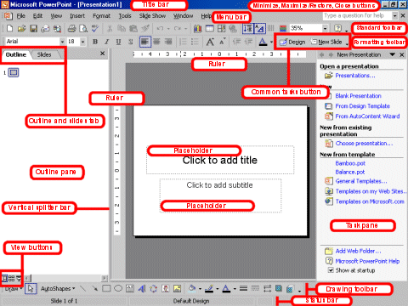

Title Bar
The Title bar generally appears at the top of the screen. The Title bar displays the title of the current presentation.

Menu Bar
The Menu bar displays the menu. You use the menu to give instructions to PowerPoint.

Standard and Formatting Toolbars
PowerPoint has several toolbars. Toolbars provide shortcuts to menu commands. The most commonly used toolbars are the Standard and Formatting toolbars. You use the Standard toolbar to do such things as open a file; save a file; print a file; check spelling; cut, copy, and paste; undo and redo; or insert a chart or table. You use the Formatting toolbar to change the font, font size or font color; bold, underline, or italicize text; left align, right align, center, or justify; bullet or number lists; highlight; or decrease or increase the indent.

Rulers
Rulers are vertical and horizontal guides. You use them to determine where you want to place an object. They are marked in inches.

Placeholders
Placeholders hold the objects in your slide. You use placeholders to hold text, clip art, and charts.

Status Bar
The Status bar generally appears at the bottom the screen. The Status bar displays the number of the slide that is currently displayed, the total number of slides, and the name of the design template in use or the name of the background.

Outline Tab
The Outline displays the text contained in your presentation.

Slides Tab
The Slides tab displays a thumbnail of all your slides. You click the thumbnail to view the slide in the Slide pane.

View Buttons
The View buttons appear near the bottom of the screen. You use the view buttons to change between Normal view, Slider Sorter view, and the Slide Show.
  - Normal View
Normal view splits you screen into three major sections: the Outline and Slides tabs, the Slide pane, and the Task pane. The Outline and Slides tabs are on the left side of your screen. They enable you to shift between two different ways of viewing your slides. The Slides tab shows thumbnails of your slides. The Outline tab shows the text on your slides. The Slide pane is located in the center of your screen. The Slide pane shows a large view of the slide on which you are currently working. The Task pane is located on the right side of your screen. The Tasks pane enables you to select the task you want to perform.

  - Slide Sorter View
Slide Sorter view enables you to view thumbnails of all your slides. In Slide Sorter view you can easily add, delete, or change the order of your slides. When you are in Slide Sorter view, a special Formatting toolbar appears. It has options that allow you to make changes to your slides
  - Slide Show
Use the Slide Show view when you want to view your slides, as they will look in your final presentation. When in Slide Show view:
Esc | Returns you to the view you were using previously.
Left-clicking | Moves you to the next slide or animation effect. When you reach the last slide, you automatically return to your last view.
Right-clicking | Opens a pop-up menu. You can use this menu to navigate the slides, add speaker notes, select a pointer, and mark your presentation.

Drawing Toolbar
The Drawing toolbar generally appears near the bottom of the screen. It contains tools for creating and editing graphics.

Common Tasks Buttons
Using the common tasks buttons, you can select the type of tasks you want to perform.

Task Pane
The Task pane enables you to select the specific task you want to perform.

Vertical Splitter Bar
You can click and drag the vertical splitter bar to change the size of your panes.

Minimize Button
You use the Minimize button to remove a window from view. While a window is minimized, its title appears on the taskbar.

Maximize/Restore Button
You use the Maximize button to cause a window to fill the screen. After you maximize a window, if you click the Restore button, the window returns to its former size.

Close Button
You use the Close button to exit the window and close the program.
Task 1: Create a power point presentation consists of slide layouts inserting text, formatting text, bullets and numbering of five slides with following information’s.
Slide 1 – contents
Slide 2 – Name
Slide 3 – Address
Slide 4 – Hobbies
Slide 5 – Figures
PURPOSE:
To maintain a PowerPoint presentation with some specifications
THEORY:
SLIDE LAYOUT:
- On the format menu, click slide layout.
- On the slides tab in normal view, select the slides; you want to apply a layout too.
- In the slide layout task pane, point to layout you and then click it.
- A new slide can also be inserted within the task pane. Point the layout you want the slide to have, click the arrow and then click the insert new slide.
INSERT TEXT:
- Text can be added to layout.
- Align text in the top, middle or bottom of a cell.
- Align text on the right or left, or in the center of a cell.
- Change cell margins.
- Insert a tab in a table.
- To make the symbol command available, in normal view, place the insertion point on the outbox tab or in a text place holders on the slide.
- On the insert menu, click symbol.
- To change fonts, click a name in the font box.

FORMATTING TEXT:
- Select the text you want to format as superscript or subscript.
- On the format menu, click font.
- To show or hide text formatting, on the standard toolbar, click show formatting.
BULLETS AND NUMBERINGS:
- Select the lines of text that you want to add bullets or numbering to.
- Click bullets or numbering.
AUTOSHAPES:
- Select the auto shape that has the text you want to position.
- Double-click the selection rectangle of the auto shape or text box and then click the text box tab in the format dialog box.
- in the text anchor point box, click the position you want the text to start in.
LINES AND ARROWS:
- In Microsoft power point, double click the chart.
- Double click the chart item you want to change.
- On the patterns tab, do one or both of the following.
- To change the colours, patterns or lines, select the options you want.
- To specify a fill effect, click fill efeect and then select the options you want on the gradient, text patterns or picture tabs.
To return to the slide, click outside the about.
PROCEDURE:
First click on start button at the button of the screen on status bar. Click on programs and then Microsoft PowerPoint. Go to file and new. Then you find different pattern of slides on right side of your screen. Then select which is completely empty. Then enter the contents in the first slide as per given information, name in the second slide, Address in the third slide, Hobbies in the fourth slide and friends in the fifth slide. Except first slide, all the second, third, fourth, fifth slides should be inserted. When you select pattern of slide from a new slide, on slide which you selected you will find an arrow towards its right side, click that arrow and then again click insert slide. Then save it. Then adjust the layout. Then format the text then give bullets or numbering to the text if required. Go to auto shapes. Select more auto shapes and insert wherever required. Then again go to insert option and select new slides. And select chart and a chart with datasheet appear. Give the name, roll no, marks in three subjects and calculate the total. Then save the file

- Introduction to MS – EXCEL

Introduction:

Microsoft Excel is one of the most widely used Spreadsheet applications for performing financial, statistical and computational analysis for the purpose of business and administration.
Microsoft Excel is a spreadsheet program. It features an intuitive interface, calculation and graphing tools. These tools could be used for business financial analysis and other administrative tasks. These features have made Excel one of the most popular microcomputer applications to date.
The tool is so flexible enough to get integrated with other applications for providing the best output. For instance, it can be integrated to web servers and the students marks, percentile etc. calculated can be generated onto the web. Similarly it can be integrated with the other Office Applications for providing Charts, Statistics etc. It can also be used as a backend database for any applications involving high-end calculation of the data that is stored.
Examples of a spreadsheet:
1. A college report card
2. A bank statement
3. A payroll sheet.
Advantages of spread sheet:
1. Large spreadsheets can be stored effortlessly on the computer.
2. Entering data is faster and easier.
3. Making changes is simpler.
4. Extracting meaningful information is easy.
5. Calculations on the spread sheet are almost error free i.e. if the data entered is correct, then the results are definitely correct.
6. The very soul of spread sheets-AUTOMATIC RECALCULATION.
Starting Microsoft Excel
- Two Ways
  - Double click on the Microsoft Excel icon on the desktop.
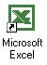

  - Click on Start --> Programs --> Microsoft Excel
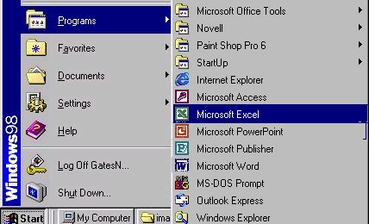

Spread Sheet Basics:
Excel allows you to create spreadsheets much like paper ledgers that can perform automatic calculations. Each Excel file is a workbook that can hold many worksheets. The worksheet is a grid of columns (designated by letters) and rows (designated by numbers). The letters and numbers of the columns and rows (called labels) are displayed in gray buttons across the top and left side of the worksheet. The intersection of a column and a row is called a cell. Each cell on the spreadsheet has a cell address that is the column letter and the row number. Cells can contain either text, numbers, or mathematical formulas.
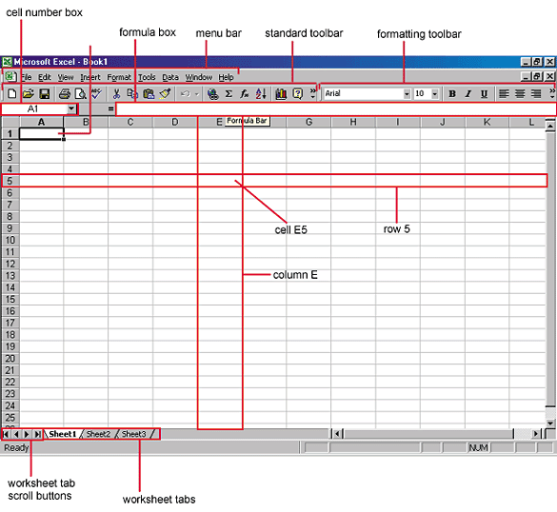
Major operations of MS Excel
1. Create, open, save, edit workbook.
2. Page setup, menu commands, and alignment.
3. Calculation in the worksheet, entering & editing a formula.
4. Working with Charts (Line chart, Bar chart, Pie chart etc.).
Overview of toolbars:
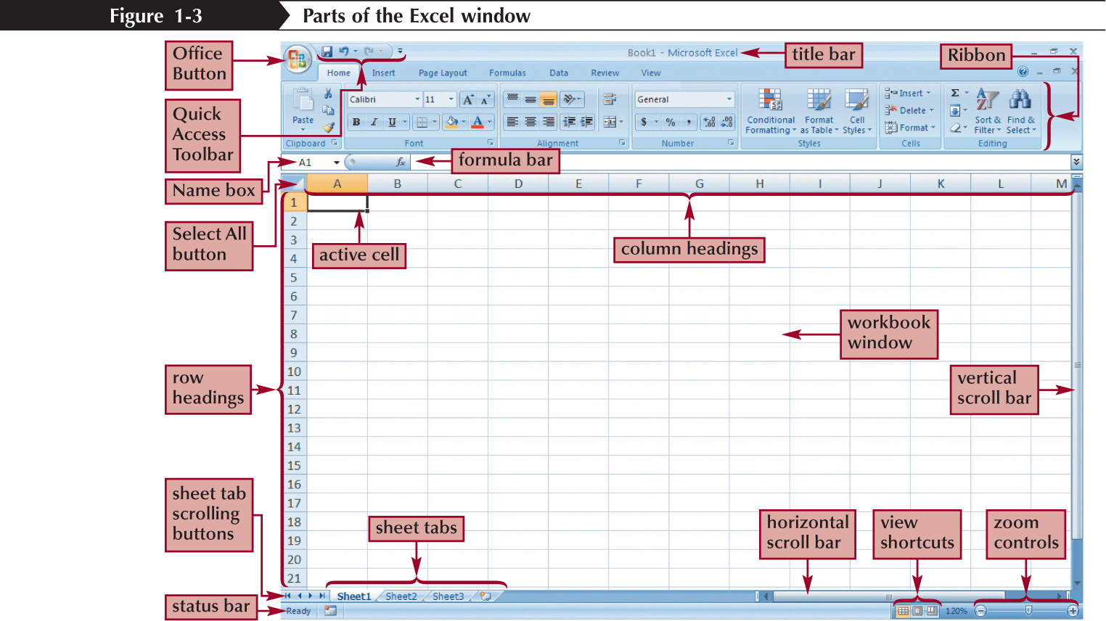
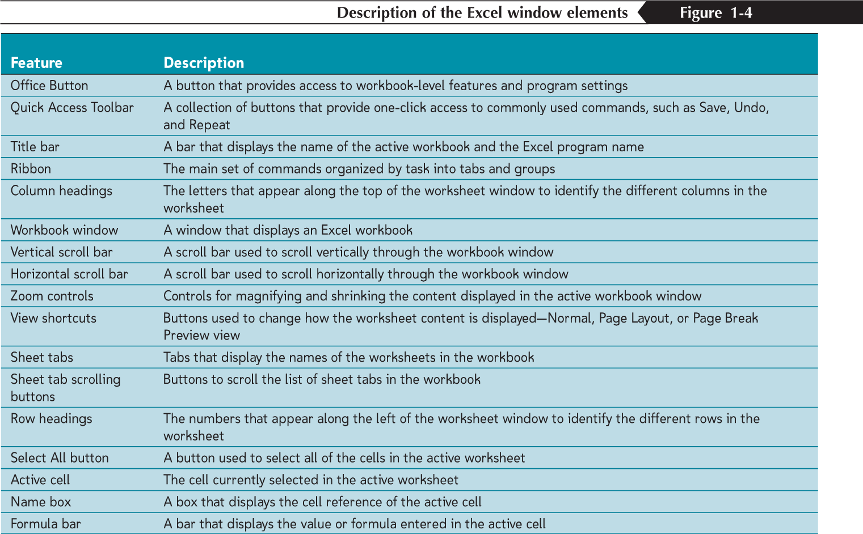

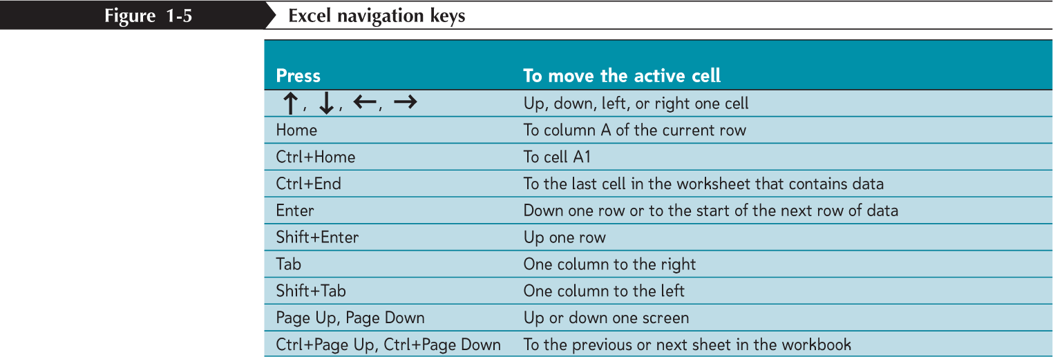
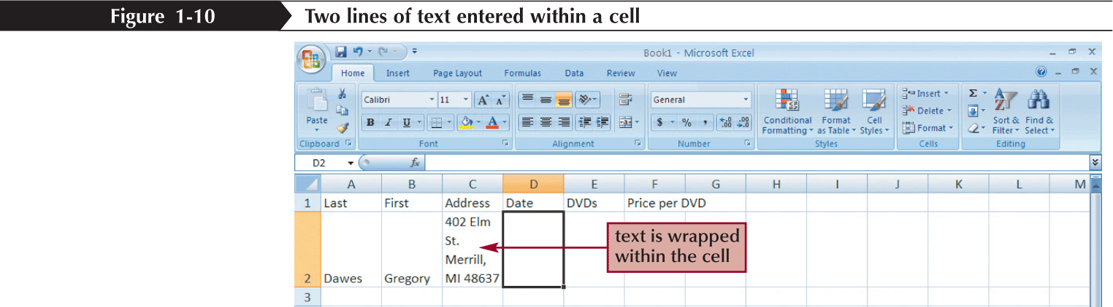
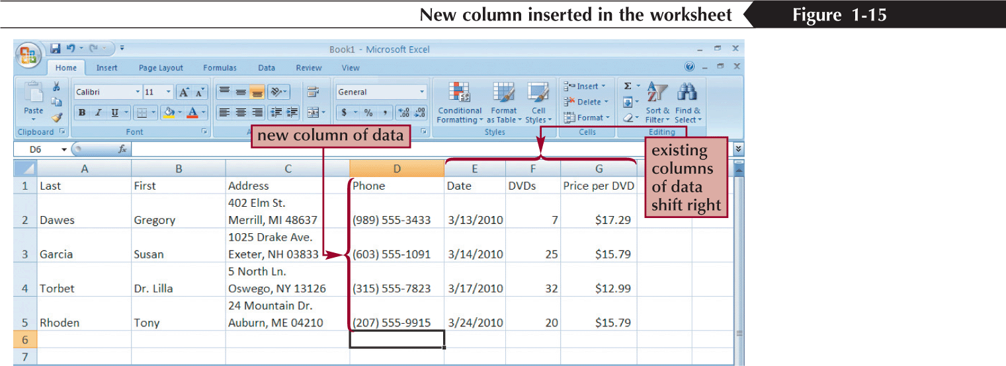

Saving excel files: 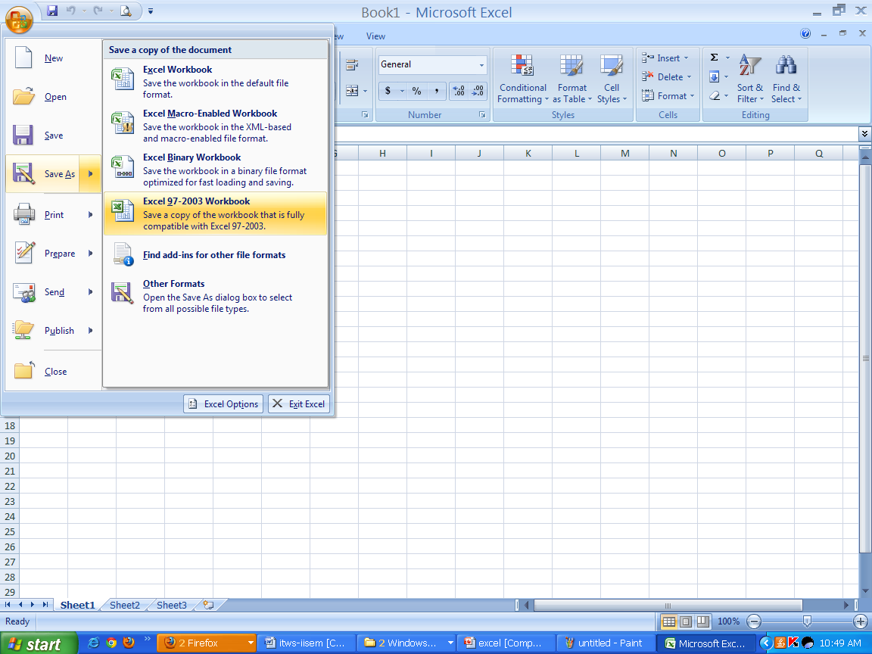
Grid lines:
Gridlines are the faint lines that appear around cells in Excel 2007. They are used to distinguish cells on the worksheet.
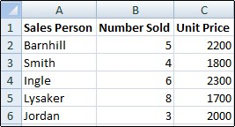
Format cells:
A style in Excel 2007 is a combination of formatting options that is named and saved as part of your current spreadsheet file. The new style can then quickly be applied to data and cells in the spreadsheet.
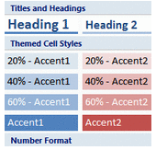
Steps to Create a Custom Formatting Style in Excel 2007
- Select a single spreadsheet cell.
- Apply all desired formatting options to this cell.
- Click the Home tab on the ribbon.
- Click on the Cell Styles option on the ribbon to open the Cell Styles gallery.
- Click on the New cell styles option at the bottom of the gallery to open the Style dialog box.
- Type a name for the new style in the Style name box.
- The formatting options already applied to the selected cell will be listed in the dialog box.

To make additional formatting options or modify the current choices:
- Click on the Format button in the Style dialog box to open the Format Cells dialog box.
- Click on the appropriate tab in the dialog box.
- Make the desired changes.
- Click OK to close the Format Cells dialog box.
- Click OK to close the Style dialog box.
- The new style is added to the top of the Cell Styles gallery
To apply the new style to cells in your spreadsheet
- Select the desired cells.
- Click the Home tab on the ribbon.
- Click on the Cell Styles option on the ribbon to open the Cell Styles gallery.
- Click on the new style name at the top of the gallery.
- The style's formatting is immediately applied to the selected cells.
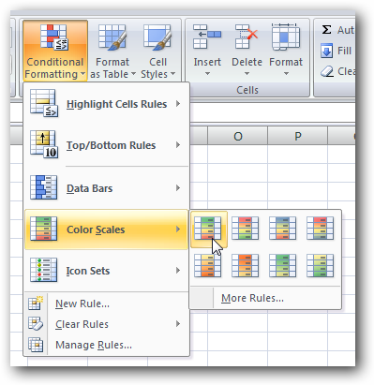
This will automatically color the items based on the range they are in…
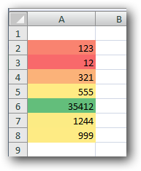
Summation:
Probably the most popular function in any spreadsheet is the SUM function. The Sum function takes all of the values in each of the specified cells and totals their values. The syntax is:
- =SUM(first value, second value, etc)
In the first and second spots you can enter any of the following (constant, cell, range of cells).
- Blank cells will return a value of zero to be added to the total.
- Text cells can not be added to a number and will produce an error.

Let's use the table here for the discussion that follows:  We will look at several different specific examples that show how the typical function can be used! Notice that in A4 there is a TEXT entry. This has NO numeric value and can not be included in a total. | A  1 25  2 50  3 75  4 test  5

Example | Cells to ADD | Answer
=sum(A1:A3) | A1, A2, A3 | 150
=sum(A1:A3, 100) | A1, A2, A3 and 100 | 250
=sum(A1+A4) | A1, A4 | #VALUE!
=sum(A1:A2, A5) | A1, A2, A5 | 75
Auto fill:
When you fill in data based on adjacent cells by dragging the fill handle in Microsoft Excel, the Auto Fill Options button is displayed just below and to the right of your filled selection. When you click the Auto Fill Options button, a list of options appears that allows you to choose to fill the cells with text or data, and whether or not to include the format of the initial selection or to copy only the format.
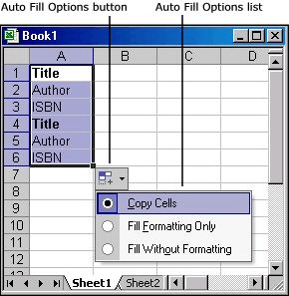
The Auto Fill Options button is also displayed after you select the AutoFill option in the Series dialog box. To show the Series dialog box, use one of the following procedures, as appropriate for the version of Excel that you are running:
- In Microsoft Office Excel 2007 and Excel 2010, click the Home tab, and then click Fill in the Editing group.
- In Microsoft Office Excel and in earlier versions of Excel, point to Fill on the Edit menu, and then click Series.
The options that are available depend on the type of content in the cells (text or numbers) and on the format of the data. You can use the Series command to find the AutoFill option and other options.
Fill down:
Often we have several cells that need the same formula (in relationship) to the location it is to be typed into. There is a short cut that is called Fill Down. There are a number of ways to perform this operation. One of the ways is to
- select the cell that has the original formula
- hold the shift key down and click on the last cell (in the series that needs the formula)
- under the edit menu go down to fill and over to down
A B C  1 5 3 =A1+B1  2 8 2 fill down  3 4 6 fill down  4 3 8 fill down | Cells information is copied from its relative position. In other words in the original cell (C1) the equation was (A1+B1). When we paste the function it will look to the two cells to the left. So the equation pasted into (C2) would be (A2+B2). And the equation pasted into (C3) would be (A3+B3). And the equation pasted into (C4) would be(A4+B4).
Fill right:
We can also fill right. We must select the original cell (and the cells to the right) and select from the Edit menu -- Fill and Right.
A B C  1 =A2+$B$3 =B2+$B$3 =C2+$B$3  2 6 2 5  3 7 10 4  4 9 8 7 | If we were to fill right from A1 to C1 we would get the formulas displayed to the left. Notice that the second part of the equation is FIXED or (ABSOLUTE REFERENCE so always references B3 which is 10).
Answers would be A1=16, B1=12, C1=15.
Formatting text:
We can use most of the tricks in our word processor to do the formatting of text. We can use : bold face, italics, underline, change the color, align (left, right, center), font size, font, etc.
We need to select the cell (or group of cells) that we wish to change the formatting and then go from the FORMAT menu -- down to CELLS -- click on FONT. Here is a picture of what you will see there. Notice that you can choose to change the alignment as well as several other options.
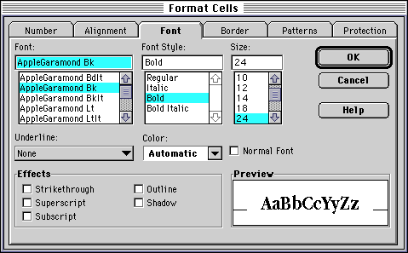

Formula in excel:
SUM:
Syntax
=SUM(number1,number2, ...)
Number1, number2, ... are 1 to 255 arguments for which you want the total value or sum

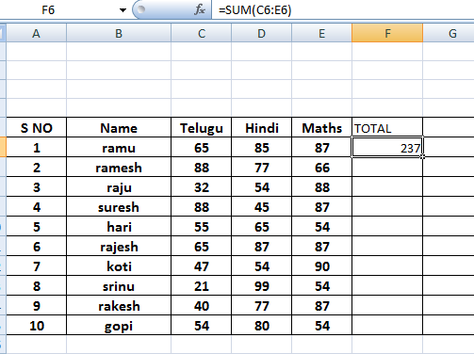

AVERAGE
Syntax
=AVERAGE(number1,number2,...)
Number1, number2, ... are 1 to 255 numeric arguments for which you want the average.
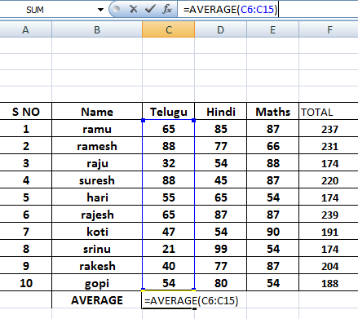

PERCENTAGE
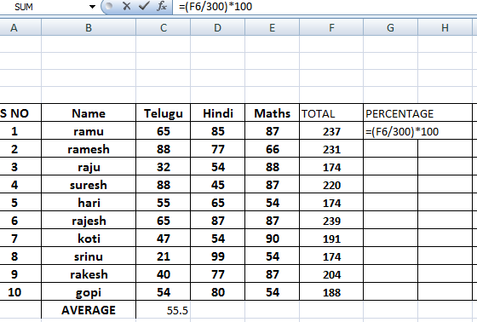
IF AND NESTED IF
Syntax
IF(logical_test,value_if_true,value_if_false)
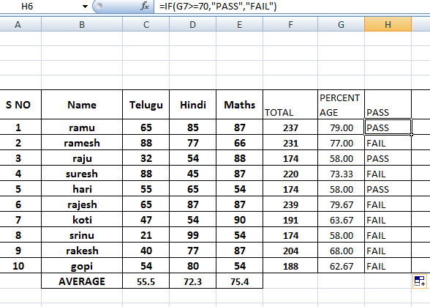
NESTED IF
Syntax
IF(logical_test,value_if_true,value_if_false)
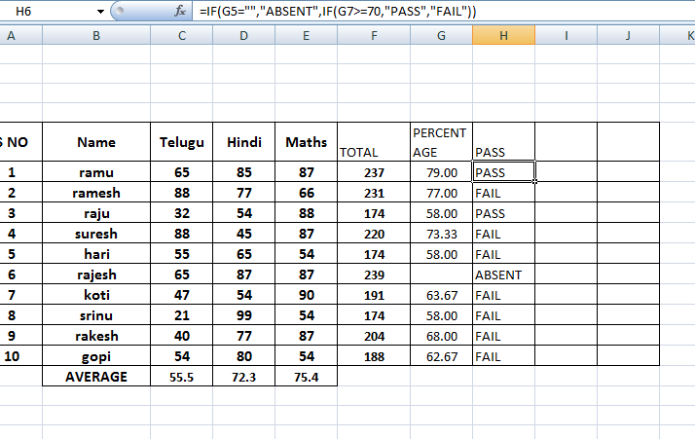
INDIRCET
=INDIRECT(ref_text,a1)
Ref_text is a reference to a cell that contains an A1-style reference, an R1C1-style reference, a name defined as a reference, or a reference to a cell as a text string. If ref_text is not a valid cell reference, INDIRECT returns the #REF! error value.
- If ref_text refers to another workbook (an external reference), the other workbook must be open. If the source workbook is not open, INDIRECT returns the #REF! error value.
- If ref_text refers to a cell range outside the row limit of 1,048,576 or the column limit of 16,384 (XFD), INDIRECT returns a #REF! error.

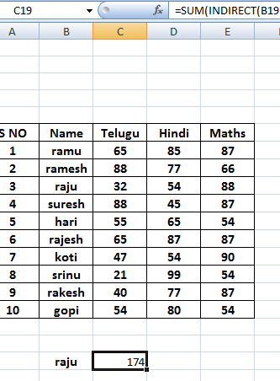

MATCH:
Syntax
MATCH(lookup_value,lookup_array,match_type)
Lookup_value is the value you use to find the value you want in a table.
- Lookup_value is the value you want to match in lookup_array. For example, when you look up someone's number in a telephone book, you are using the person's name as the lookup value, but the telephone number is the value you want.
- Lookup_value can be a value (number, text, or logical value) or a cell reference to a number, text, or logical value.
- 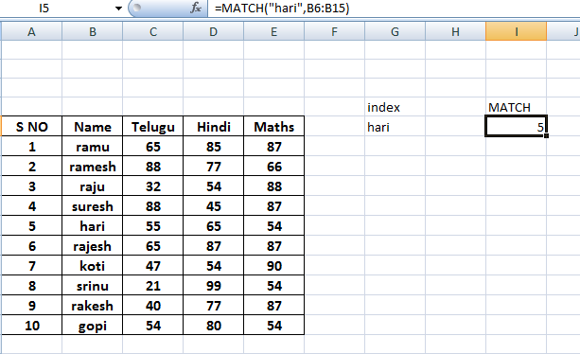

INDEX:
=INDEX(array,row_num,column_num)
Array is a range of cells or an array constant.
- If array contains only one row or column, the corresponding row_num or column_num argument is optional.
- If array has more than one row and more than one column, and only row_num or column_num is used, INDEX returns an array of the entire row or column in array.
Row_num selects the row in array from which to return a value. If row_num is omitted, column_num is required.
Column_num selects the column in array from which to return a value. If column_num is omitted, row_num is required.

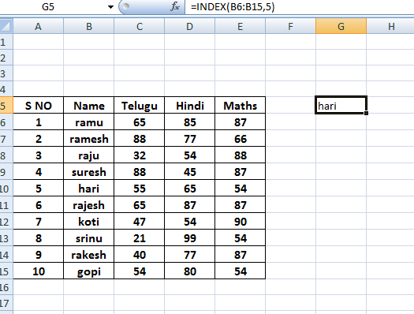

COUNT:
Syntax
=COUNT(value1,value2,...)
Value1, value2, ... are 1 to 255 arguments that can contain or refer to a variety of different types of data, but only numbers are counted.
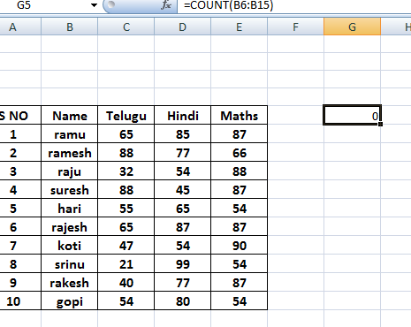
COUNTA:
Syntax
=COUNTA(value1,value2,...)
Value1, value2, ... are 1 to 255 arguments representing the values you want to count.
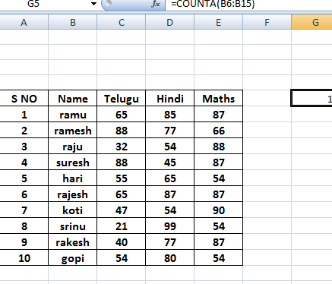
TODAY,NOW,DATE AND TIME
Syntax
=TODAY( )
Syntax
=DATE(year,month,day)
Syntax
=NOW( )
Syntax
=TIME(hour,minute,second)
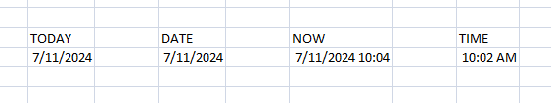

PROPER,LOWER AND UPPER
Syntax
=PROPER(text)
Syntax
=UPPER(text)
Syntax
=LOWER(text)
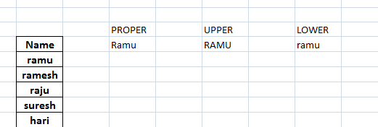

ROUND, ROUNDDOWN AND ROUNDUP
Syntax
ROUND(number,num_digits)
Number is the number you want to round.
Num_digits specifies the number of digits to which you want to round number.
Syntax
ROUNDDOWN(number,num_digits)
Number is any real number that you want rounded down.
Num_digits is the number of digits to which you want to round number.
Syntax
ROUNDUP(number,num_digits)
Number is any real number that you want rounded up.
Num_digits is the number of digits to which you want to round number.
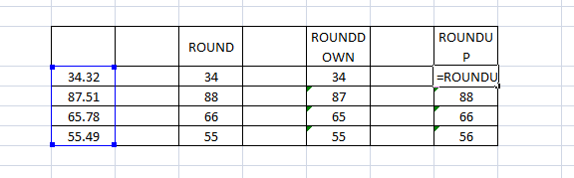
CONCATENATE
Syntax
=CONCATENATE (text1,text2,...)

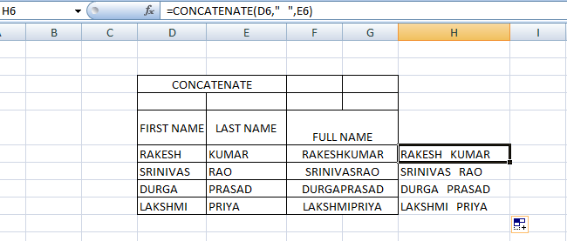
REPLACE
Syntax
=REPLACE(old_text,start_num,num_chars,new_text)
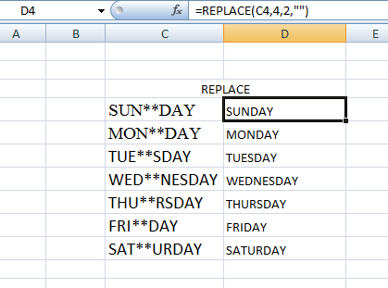
REPEAT:
Syntax
=REPT(text,number_times)
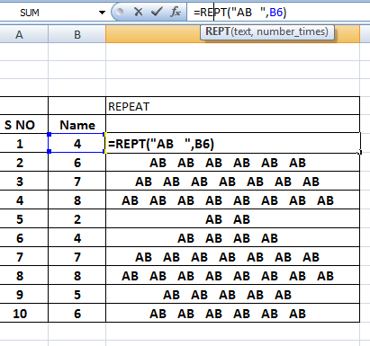

VLOOKUP

Syntax
VLOOKUP(lookup_value,table_array,col_index_num,range_lookup)
Lookup_value The value to search in the first column of the table array. Lookup_value can be a value or a reference. If lookup_value is smaller than the smallest value in the first column of table_array, VLOOKUP returns the #N/A error value.
Table_array Two or more columns of data. Use a reference to a range or a range name. The values in the first column of table_array are the values searched by lookup_value. These values can be text, numbers, or logical values. Uppercase and lowercase text are equivalent.
Col_index_num The column number in table_array from which the matching value must be returned. A col_index_num of 1 returns the value in the first column in table_array; a col_index_num of 2 returns the value in the second column in table_array, and so on. If col_index_num is:
- Less than 1, VLOOKUP returns the #VALUE! error value.
- Greater than the number of columns in table_array, VLOOKUP returns the #REF! error value.
Range_lookup A logical value that specifies whether you want VLOOKUP to find an exact match or an approximate match:
- If TRUE or omitted, an exact or approximate match is returned. If an exact match is not found, the next largest value that is less than lookup_value is returned.
The values in the first column of table_array must be placed in ascending sort order; otherwise, VLOOKUP may not give the correct value. For more information, see Sort data.
- If FALSE, VLOOKUP will only find an exact match. In this case, the values in the first column of table_array do not need to be sorted. If there are two or more values in the first column of table_array that match the lookup_value, the first value found is used. If an exact match is not found, the error value #N/A is returned.

